**系統性文獻搜尋紀錄表（學習單）**

**〔出席資格〕登記參加課程意願後，於9/9前填寫並繳交本表之「1.研究問題」、「2.檢索詞」(黃底處為必填欄位)，詳見該區演練說明**

〔您的姓名〕\_\_\_\_ \_\_\_\_\_\_\_

〔務必選一〕是否願意將您的題目，於「本次課堂」中做為講師示範之用？

(1)可公開討論全部 (解說時揭露姓名：是 否)

(2)可公開討論局部：講師擇PICO其中一項較不具識別性的元素來做展示，亦可自行指定：\_\_\_\_\_\_ (解說時揭露姓名：是 否)

(3)須保密題目：僅於課堂演練時個別諮詢 (每位時間將考量整體狀況來調整)

1. **研究問題：**自備題目練習)

|  |  |
| --- | --- |
| **Question:** |  |
| Population |  |
| **I**ntervention |  |
| **C**omparison |  |
| **O**utcome |  |
| 問題類型： | Therapy/Prevention Diagnosis Etiology Other: |
| 收錄研究設計： | RCTs  Cohort Studies Systematic Reviews Other: |
| 我的研究設計： | SR/MA Scoping Review Umbrella Review Other: |
| 備註： |  |

1. **檢索詞**

〔演練說明〕

1. 至少完成您題目的任二個主題概念(例P、I或其他)之英文同義字與控制詞彙(Emtree / MeSH)
2. 完成練習或理解時，請打勾「蒐集來源」、「重要檢核」各項目 (無法理解可加註於問題處)
3. 搭配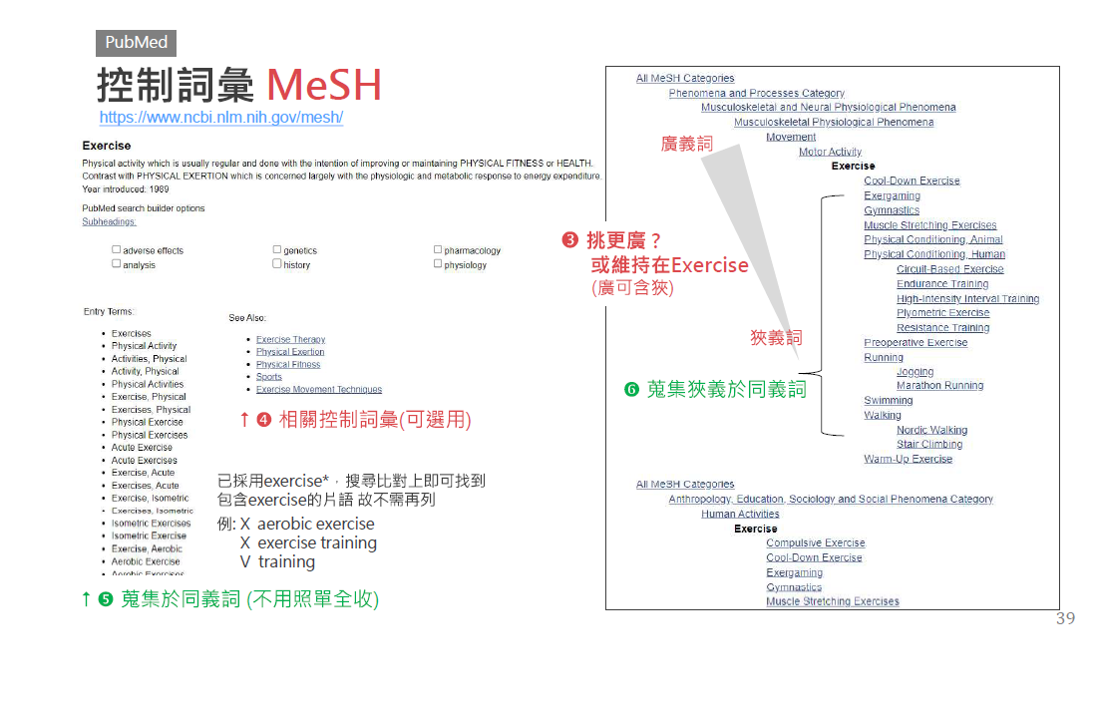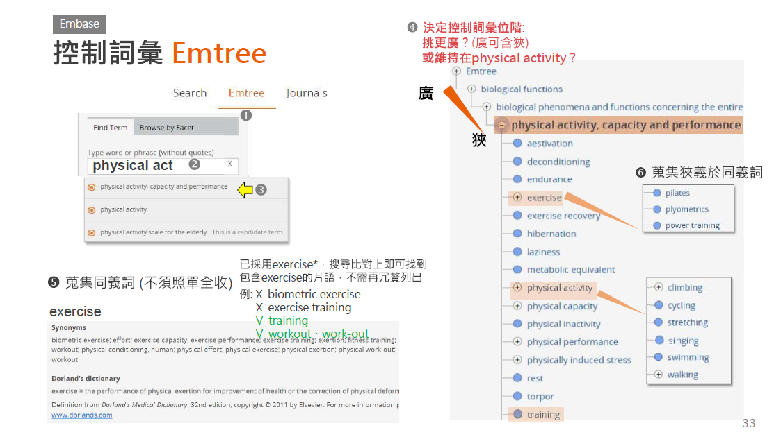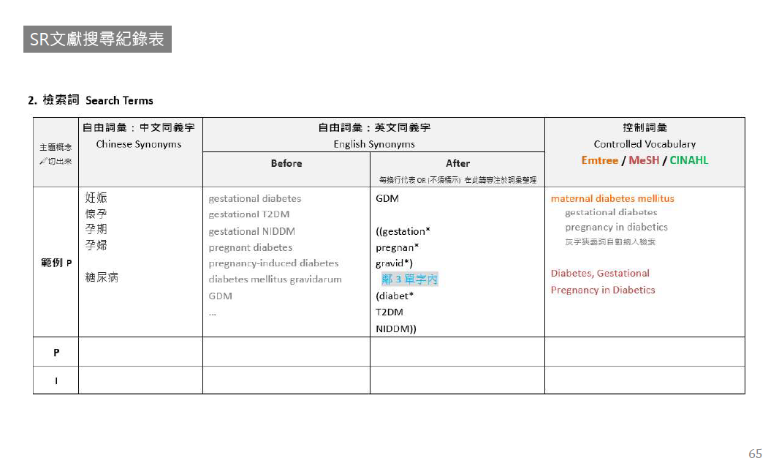參考講義[(下載)](https://hdrive.hosp.ncku.edu.tw/s/F8TJCXSC)p.31-p.65 或範例紀錄表[(下載)](https://hdrive.hosp.ncku.edu.tw/s/HXLOFMCH)

….

|  |  |  |  |  |
| --- | --- | --- | --- | --- |
| 主題概念 🔪切出來 | **自由詞彙：中文同義字**  Chinese Synonyms  可省略不寫 | **自由詞彙：英文同義字**  English Synonyms | | **控制詞彙**  Controlled Vocabulary  **Emtree / MeSH / CINAHL** |
| **Before** | **After**  每換行代表OR (不須標示) 在此請專注於詞彙整理 |
| **範例P** | 妊娠  懷孕 孕期  孕婦  糖尿病 | gestational diabetes  gestational T2DM  gestational NIDDM  pregnant diabetes  pregnancy-induced diabetes  diabetes mellitus gravidarum  GDM  … | GDM  ((gestation\*  pregnan\*  gravid\*)  鄰3單字內  (diabet\*  T2DM  NIDDM)) | maternal diabetes mellitus  gestational diabetes  pregnancy in diabetics  灰字狹義詞自動納入檢索  Diabetes, Gestational  Pregnancy in Diabetics |
| **P** |  |  |  |  |
| **I** |  |  |  |  |
| **C** |  |  |  |  |
| **O** |  |  |  |  |
| **蒐集 管道** |  | ❶控制詞彙表之同義詞清單  ❷控制詞彙表之狹義控制詞彙  ❸Cochrane SR: Search Strategies ⭢Appendices; Supplementary; Methods  ❹瀏覽相關文章  ❺ChatGPT [🠢發問架構](https://www.notion.so/ncku-medlib/ChatGPT-AI-2ead086e8d9d4bae9327cb94dd85b433#268b21c6891742129578615a23a82bd6) | | ❶詞表查詢＞決定控制詞彙位階(廣/狹)  ❷高相關文章的控制詞彙給了甚麼 ⭢index term, index miner, subject filter  ❸Cochrane SR: Search Strategies  ⭢ Appendices; Supplementary; Methods  ❹交叉檢查不同控制詞彙表的對應：若Embase有某個控制詞彙，應該推想另一個資料庫(MEDLINE等)也可能有對應的控制詞彙，反之亦然 |
| **重要 檢核** |  | ❶單字切截處理  ▪跨庫通用性，建議使用字尾切截\*，並使至少要包含名詞單複數， 必要時再擴至形容詞與動詞  ▪字頭起始太短時，避免使用切截  例：hear\*誤找heart。解法⭢直接列出可能字尾變化hear、hearing  ❷詞彙去冗: 輸入一個單字(詞)即能找出含括者，不需冗贅列出  例: 使用exercise即能找到**exercise** therapy、physical **exercise**…  例: 使用"quality of life"能找到"health-related **quality of life**"  無法找到"life quality", "quality-adjusted of life"  ❸指定單字間的距離：一個詞彙由兩個單字(含以上)組成時 例gestational diabetes，必須指定其為下列三種關係之一 文章數由多到少如下，建議採用鄰近字或片語(超重要!)  ▪交集: (gestational AND diabetes)  ▪鄰近字: (gestational 鄰n單字內 diabetes)  有多個同義詞群時，並可簡化表達，請參考After範例  ▪片語: "gestational diabetes"  採"雙直引號" 優於 “上下引號” [🠢設定說明](https://ncku-medlib.notion.site/Word-2741eafc5ad4415e82f2c33f8803f2e9)  ➍連字符號: 例anti-cancer = "anti cancer" ≠ anticancer  ❺所有格: "Parkinson\* Disease\*"  在Embase無法找出 "Parkinson's Disease\*" ('s被視為一個單字)  三解法擇一: ▪ 只輸入Parkinson\* (當不會找到太多非疾病時)  ▪ (Parkinson\* NEXT/2 Disease\*)  ▪ "Parkinson\* Disease\*" OR "Parkinson s Disease\*" (勿用單引號's)  ➏舒適閱讀很重要，檢索詞大小寫法請一致 | | ❶控制詞彙無切截用法 ⮿Exercise\*  ❷控制詞彙的廣狹義(位階)  ▪無互屬：適用都列出  Exercise、Exercise Therapy  ▪有互屬：列出最適用位階詞 (皆列出亦可) Exercise廣於Running 使用Exercise即可指定包含Running  語法將設定自動納入所有狹義詞 筆記時請利用縮格呈現廣狹義，有利釐清關係 可標灰表示不需檢索 |

1. **搜尋資料庫**〔不需填寫〕

|  |  |  |  |  |  |  |  |  |  |  |
| --- | --- | --- | --- | --- | --- | --- | --- | --- | --- | --- |
| **資料庫**  Database | **新文通知**  Alert | **搜尋日期**  Date searched | **筆數Citations** | | | | | | | |
| **搜尋結果**  Records identified from | **篇名摘要待篩選**  Records screened | | **全文待獲取**  Reports sought for retrieval | | **全文待篩選**  Reports assessed for eligibility | | **納入分析** Included |
| 1. Embase |  |  |  | **included:** | | **included:** | | **included:** | | **Studies included in review:**  **Reports of included studies:** |
| 1. MEDLINE (Ovid)   或PubMed二擇一 |  |  |  |
| 1. Cochrane CENTRAL |  |  |  |
| 1. CINAHL (EBSCOhost) |  |  |  |
| 1. Scopus或WOS |  |  |  |
| 1. ICTRP |  |  |  |
| other sources | - | - |  |
| **文獻篩選流程**[**PRISMA flow diagram**](http://prisma-statement.org/PRISMAStatement/FlowDiagram)**:**  篩選流程管理與去重複書目，可利用相關工具，例如EndNote、Rayyan等進行管理。 | | | **included:** |
| **de-duplicates:** | | **excluded:** | | **excluded:** | | **excluded:**  說明排除理由 | |

1. **搜尋策略Search Strategy**（投稿時附上此項為Appendix）

〔自由提前練習〕根據您蒐集的檢索詞，嘗試完成Embase的P I搜尋策略與執行

|  |  |  |  |
| --- | --- | --- | --- |
| **資料庫** Database | # | **搜尋語法** Search syntax | **結果筆數**Citations found |
| **Embase.com (Elsevier)** | 例1 | P自由詞彙  GDM OR ((gestation\* OR pregnan\* OR gravid\*) N3 (diabet\* OR T2DM OR NIDDM)) |  |
| 例2 | P控制詞彙CINAHL Subject Heading  mh "Diabetes Mellitus, Gestational+" OR mh "Pregnancy in Diabetes+"  逐一附加⭡ 或 整串附加⭣ mh  mh ("Diabetes Mellitus, Gestational+" OR "Pregnancy in Diabetes+") |  |
| 1 | P自由詞彙 | [Ctrl+H]  尋找目標^p 取代為 OR  ***(留意OR前後空格須包含)*** |
| 2 | P控制詞彙CINAHL Subject Heading | [Ctrl+H]  尋找目標^p 取代為"/exp OR " |
| 3 | I自由詞彙 |  |
| 4 | I控制詞彙Emtree |  |
| 5 | O自由詞彙 |  |
| 6 | O控制詞彙Emtree |  |
| 7 | (#1 OR #2) AND (#3 OR #4) AND (#5 OR #6) AND [embase]/lim | All: |
| 8 | #7 AND 附錄2 (複製貼上) | **RCT:** |
| **MEDLINE (Ovid)** and Epub Ahead of Print, In-Process, In-Data-Review & Other Non-Indexed Citations | 例1 | P自由詞彙  (GDM OR ((gestation\* OR pregnan\* OR gravid\*) ADJ4 (diabet\* OR T2DM OR NIDDM))).ti,ab,kf | [Ctrl+H]  尋找目標^p 取代為"/ OR exp " |
| 例2 | P控制詞彙MeSH  exp "Diabetes, Gestational"/ OR exp "Pregnancy in Diabetics"/ |  |
| 1 | P自由詞彙 |  |
| 2 | P控制詞彙MeSH | [Ctrl+H]  尋找目標^p 取代為"/ OR exp " |
| 3 | I自由詞彙 |  |
| 4 | I控制詞彙MeSH |  |
| 5 | O自由詞彙 |  |
| 6 | O控制詞彙MeSH |  |
| 7 | (1 OR 2) AND (3 OR 4)  不加# | ALL: |
| 8 | 7 AND 附錄2 (複製貼上) | **RCT:** |
| **Cochrane Library: Trials (CENTRAL)**  專收RCT研究設計，但非RCT研究若基於RCT所延續發表等，亦有可能收錄其中。若您的研究僅收RCT，可以自行衡量是否要加入此資料庫檢索)  注意:自2023/6起不支援鄰近字與切截併用，需修改語法為NEXT  🗷 "pregnan\* diabet\*  🗹 (pregnan\* NEXT diabetes)  🗷 "post operat\*"  🗹 (post-operat\*)  🗷 "post\*-operat\*" | 例1 | P自由詞彙  (GDM OR ((gestation\* OR pregnan\* OR gravid\*) NEAR/4 (diabet\* OR T2DM OR NIDDM))):ti,ab,kw |  |
| 例2 | P控制詞彙MeSH  [mh "Diabetes, Gestational"] OR [mh "Pregnancy in Diabetics"] |  |
| 1 | P自由詞彙 |  |
| 2 | P控制詞彙MeSH | 複製MEDLINE後: [Ctrl+H]  尋找目標/ OR exp 取代為] OR [mh |
| 3 | I自由詞彙 |  |
| 4 | I控制詞彙MeSH |  |
| 5 | O自由詞彙 |  |
| 6 | O控制詞彙MeSH |  |
| 7 | (#1 OR #2) AND (#3 OR #4) AND (#5 OR #6) | All: |
| 8 | #7 (用選單Limits: in Trials, Cochrane Reviews, Cochrane Protocols) | **RCT:** |
| **CINAHL (EBSCOhost)**  進階查詢:所有查詢建議均不勾選  🞏 Apply related words  🞏 Apply equivalent subjects | 例1 | P自由詞彙  GDM OR ((gestation\* OR pregnan\* OR gravid\*) N3 (diabet\* OR T2DM OR NIDDM)) |  |
| 例2 | P控制詞彙CINAHL Subject Heading  mh "Diabetes Mellitus, Gestational+" OR mh "Pregnancy in Diabetes+"  逐一附加⭡ 或 整串附加⭣ mh  mh ("Diabetes Mellitus, Gestational+" OR "Pregnancy in Diabetes+") |  |
| 1 | P自由詞彙 |  |
| 2 | P控制詞彙CINAHL Subject Heading |  |
| 3 | I自由詞彙 |  |
| 4 | I控制詞彙CINAHL Subject Heading |  |
| 5 | O自由詞彙 |  |
| 6 | O控制詞彙CINAHL Subject Heading |  |
| 7 | (S1 OR S2) AND (S3 OR S4) AND (S5 OR S6) | All: |
| 8 | S7 AND附錄2 (複製貼上) | **RCT:** |
| **Web of Science**  **在進階介面輸入**  (無控制詞彙) | 例1 | P自由詞彙  **TS = (**GDM OR ((gestation\* OR pregnan\* OR gravid\*) NEAR/3 (diabet\* OR T2DM OR NIDDM))**)** |  |
| 1 | P自由詞彙 |  |
| 2 | I自由詞彙 |  |
| 3 | O自由詞彙 |  |
| 4 | #1 AND #2 AND #3 | All: |
| 5 | #4 AND附錄2 (複製貼上) | **RCT:** |
| 例1 | P自由詞彙  **TS = (**GDM OR ((gestation\* OR pregnan\* OR gravid\*) NEAR/3 (diabet\* OR T2DM OR NIDDM))**)** |  |

1. **檢索截圖／備忘**

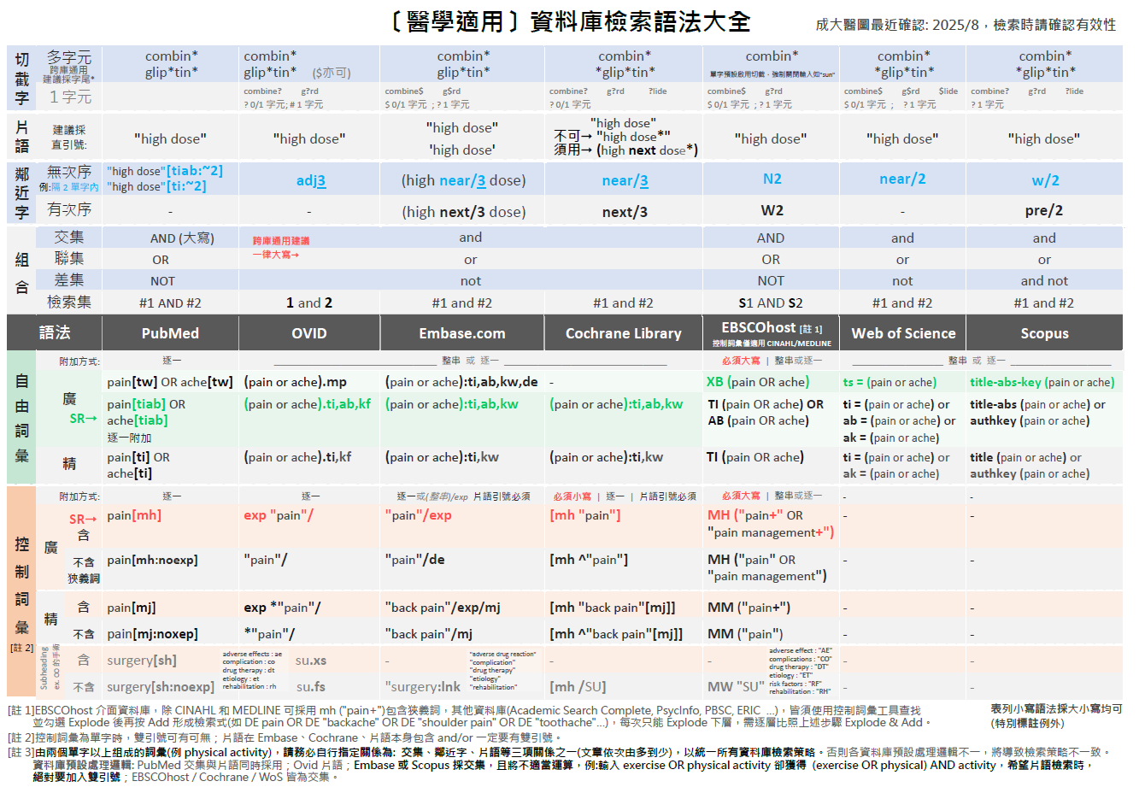

**附錄1**

**附錄2: 研究設計篩選語法：**不同問題類型/研究設計、資料庫/平台，套用的Filters各異

更多篩選語法：

CADTH <https://searchfilters.cda-amc.ca>

ISSG <https://sites.google.com/a/york.ac.uk/issg-search-filters-resource/>

更多篩選語法：

CADTH <https://searchfilters.cda-amc.ca>

ISSG <https://sites.google.com/a/york.ac.uk/issg-search-filters-resource/>

**附錄2-1: RCT** (Cochrane Trials: CENTRAL即收錄RCT，無須套用Filter)

|  |  |  |  |  |  |  |
| --- | --- | --- | --- | --- | --- | --- |
| **Embase.com (Elsevier)** | **Embase (Ovid)** | **Medline (Ovid)** | **Medline (PubMed)** | **CINAHL (EBSCOhost)** | **PsycInfo (Ovid)** | **Web of Science** |
| ("randomized controlled trial"/de or "controlled clinical study"/de or "randomization"/de or "intermethod comparison"/de or "double blind procedure"/de or "human experiment"/de OR (random\* or placebo or "parallel group$" or crossover or "cross over" or assigned or allocated or volunteer or volunteers):ti,ab OR (open NEAR/1 label):ti,ab OR ((double or single or doubly or singly) NEAR/1 (blind or blinded or blindly)):ti,ab OR ((assign\* or match or matched or allocation) NEAR/5 (alternate or group$ or intervention$ or patient$ or subject$ or participant$)):ti,ab OR (controlled NEAR/7 (study or design or trial)):ti,ab OR (compare or compared or comparison or trial):ti OR ((evaluated or evaluate or evaluating or assessed or assess) and (compare or compared or comparing or comparison)):ab) NOT (((random\* NEAR/1 sampl\* NEAR/7 ("cross section\*" or questionnaire$ or survey\* or database$)):ti,ab not ("comparative study"/de or "controlled study"/de or "randomi$ed controlled":ti,ab or "randomly assigned":ti,ab)) OR ("cross-sectional study"/de not ("randomized controlled trial"/de or "controlled clinical study"/de or "controlled study"/de or "randomi$ed controlled":ti,ab or "control group$":ti,ab)) OR ((((case NEAR/1 control\*) and random\*) not "randomi$ed controlled"):ti,ab) OR (("systematic review" not (trial or study)):ti) OR ((nonrandom\* not random\*):ti,ab) OR ("random field\*":ti,ab) OR (("random cluster" NEAR/3 sampl\*):ti,ab) OR ((review:ab and review/it) not trial:ti) OR ("we searched":ab and (review:ti or review/it)) OR ("update review":ab) OR ((databases NEAR/4 searched):ab) OR ((rat or rats or mouse or mice or swine or porcine or murine or sheep or lambs or pigs or piglets or rabbit or rabbits or cat or cats or dog or dogs or cattle or bovine or monkey or monkeys or trout or marmoset\*):ti and "animal experiment"/de) OR ("animal experiment"/de not ("human experiment"/de or "human"/de)))  Filter Source: Box 3.e, [Technical Supplement to Chapter 4: Searching for and Selecting Studies](https://training.cochrane.org/handbook/version-6/chapter-4-tech-suppl). Cochrane Handbook for Systematic Reviews of Interventions Version 6. (Syntax Translated from Ovid Embase to Elsevier Embase.com. 原出處Ovid Embase版，且為逐行檢索，此已由成大醫圖轉換並合併為一串)  (若此語法找出總文章量過多，可以洽詢改用其他RCTs語法) | **(**(Randomized controlled trial/) OR (Controlled clinical study/) OR (random$.ti,ab.) OR (randomization/) OR (intermethod comparison/) OR (placebo.ti,ab.) OR ((compare or compared or comparison).ti.) OR (((evaluated or evaluate or evaluating or assessed or assess) and (compare or compared or comparing or comparison)).ab.) OR ((open adj label).ti,ab.) OR (((double or single or doubly or singly) adj (blind or blinded or blindly)).ti,ab.) OR (double blind procedure/) OR (parallel group$1.ti,ab.) OR ((crossover or cross over).ti,ab.) OR (((assign$ or match or matched or allocation) adj5 (alternate or group$1 or intervention$1 or patient$1 or subject$1 or participant$1)).ti,ab.) OR ((assigned or allocated).ti,ab.) OR ((controlled adj7 (study or design or trial)).ti,ab.) OR ((volunteer or volunteers).ti,ab.) OR (human experiment/) OR (trial.ti.)**) NOT (**(random$ adj sampl$ adj7 ("cross section$" or questionnaire$1 or survey$ or database$1).ti,ab.) not (comparative study/ or controlled study/ or randomi?ed controlled.ti,ab. or randomly assigned.ti,ab.) OR (Cross-sectional study/ not (randomized controlled trial/ or controlled clinical study/ or controlled study/ or randomi?ed controlled.ti,ab. or control group$1.ti,ab.)) OR ((((case adj control$) and random$) not randomi?ed controlled).ti,ab.) OR ((Systematic review not (trial or study)).ti.) OR ((nonrandom$ not random$).ti,ab.) OR ("Random field$".ti,ab.) OR ((random cluster adj3 sampl$).ti,ab.) OR ((review.ab. and review.pt.) not trial.ti.) OR ("we searched".ab. and (review.ti. or review.pt.)) OR ("update review".ab.) OR ((databases adj4 searched).ab.) OR ((rat or rats or mouse or mice or swine or porcine or murine or sheep or lambs or pigs or piglets or rabbit or rabbits or cat or cats or dog or dogs or cattle or bovine or monkey or monkeys or trout or marmoset$1).ti. and animal experiment/) OR (Animal experiment/ not (human experiment/ or human/))**)**  Filter Source: Box 3.e, [Technical Supplement to Chapter 4: Searching for and Selecting Studies](https://training.cochrane.org/handbook/version-6/chapter-4-tech-suppl). Cochrane Handbook for Systematic Reviews of Interventions Version 6. (原出處為逐行檢索，此已由成大醫圖合併為一串) | **sensitivity-maximizing (優先採用):**  (randomized controlled trial.pt. or controlled clinical trial.pt. or randomi\*ed.ab. or placebo.ab. or drug therapy.fs. or randomly.ab. or trial.ab. or groups.ab. not (exp animals/ not humans.sh.))  Filter Source: Box 3.c, [Technical Supplement to Chapter 4: Searching for and Selecting Studies.](https://training.cochrane.org/handbook/version-6/chapter-4-tech-suppl) Cochrane Handbook for Systematic Reviews of Interventions Version 6. (Add: randomised.ab) | **sensitivity-maximizing(優先採用):**  (randomized controlled trial[pt] OR controlled clinical trial[pt] OR randomi\*ed[tiab] OR placebo[tiab] OR drug therapy[sh] OR randomly[tiab] OR trial[tiab] OR groups[tiab] NOT (animals[mh] NOT humans[mh]))  Filter Source: Box 3.a, [Technical Supplement to Chapter 4: Searching for and Selecting Studies.](https://training.cochrane.org/handbook/version-6/chapter-4-tech-suppl) Cochrane Handbook for Systematic Reviews of Interventions Version 6. (Add: randomized[tiab]) | ((MH ("randomized controlled trials" OR "double‐blind studies" OR "single‐blind studies" OR "random assignment" OR "pretest‐posttest design" OR "cluster sample") OR TI (randomised OR randomized) OR AB (random\*) OR TI (trial) OR (MH (sample size) AND AB (assigned OR allocated OR control)) OR MH (placebos) OR PT (randomized controlled trial) OR AB (control W5 group) OR MH ("crossover design" OR "comparative studies") OR AB (cluster W3 RCT)) NOT ((MH ("animals+" OR "animal studies") OR TI (animal model\*)) NOT MH (human)))  Filter Source: Box 3.f., [Technical Supplement to Chapter 4: Searching for and Selecting Studies.](https://training.cochrane.org/handbook/version-6/chapter-4-tech-suppl) Cochrane Handbook for Systematic Reviews of Interventions Version 6. | **Watson et al:**  ("Treatment Effectiveness Evaluation"/ OR exp "Treatment Outcomes"/ OR "Placebo"/ OR "Followup Studies"/ OR (placebo\* OR random\* OR "comparative stud\*" OR (clinical ADJ4 trial\*) OR (research ADJ4 design) OR (evaluat\* ADJ4 stud\*) OR (prospectiv\* ADJ4 stud\*) OR ((singl\* OR doubl\* OR trebl\* OR tripl\*) ADJ4 (blind\* OR mask\*))).mp)  **Eady et al:**  **Best sensitivity:**  ((random\* OR control\*).mp OR exp "treatment"/)  **Best optimization of sensitivity and specificity:** ("double-blind" OR "random\* assigned" OR control).mp  Filter Source: Eady AM, Wilczynski NL, Haynes RB. PsycINFO search strategies identified methodologically sound therapy studies and review articles for use by clinicians and researchers. Journal of Clinical Epidemiology. 2008 Jan;61(1):34-40.  本區參考[Cochrane](http://work.cochrane.org/psycinfo)推薦ProQuest介面語法，修改為Ovid介面語法 | (TS= clinical trial\* OR TS=research design OR TS=comparative stud\* OR TS=evaluation stud\* OR TS=controlled trial\* OR TS=follow-up stud\* OR TS=prospective stud\* OR TS=random\* OR TS=placebo\* OR TS=(single blind\*) OR TS=(double blind\*))  Filter Source: [American University of Beirut](https://aub.edu.lb.libguides.com/c.php?g=329862&p=3023731) |
| **sensitivity- and precision-maximizing (折衷採用):**  (randomized controlled trial.pt. or controlled clinical trial.pt. or randomi\*zed.ab. or placebo.ab. or clinical trials as topic.sh. or randomly.ab. or trial.ti. NOT (exp animals/ not humans.sh.))  Filter Source: Box 3.d, [Technical Supplement to Chapter 4: Searching for and Selecting Studies.](https://training.cochrane.org/handbook/version-6/chapter-4-tech-suppl) Cochrane Handbook for Systematic Reviews of Interventions Version 6. (Add: randomised.ab) | **sensitivity- and precision-maximizing (折衷採用):**  (randomized controlled trial[pt] OR controlled clinical trial[pt] OR randomi\*ed[tiab] OR placebo[tiab] OR clinical trials as topic[mesh:noexp] OR randomly[tiab] OR trial[ti] NOT (animals[mh] NOT humans [mh]))  Filter Source: Box 3.b, [Technical Supplement to Chapter 4: Searching for and Selecting Studies.](https://training.cochrane.org/handbook/version-6/chapter-4-tech-suppl) Cochrane Handbook for Systematic Reviews of Interventions Version 6. (Add: randomized[tiab]) | **Scopus** |
| (INDEXTERMS ( "clinical trials" OR "clinical trials as a topic" OR "randomized controlled trial" OR "Randomized Controlled Trials as Topic" OR "controlled clinical trial" OR "Controlled Clinical Trials" OR "random allocation" OR "Double-Blind Method" OR "Single-Blind Method" OR "Cross-Over Studies" OR "Placebos" OR "multicenter study" OR "double blind procedure" OR "single blind procedure" OR "crossover procedure" OR "clinical trial" OR "controlled study" OR "randomization" OR "placebo" ) OR TITLE-ABS-KEY ( "clinical trials" OR "clinical trials as a topic" OR "randomized controlled trial" OR "Randomized Controlled Trials as Topic" OR "controlled clinical trial" OR "Controlled Clinical Trials as Topic" OR "random allocation" OR "randomly allocated" OR "allocated randomly" OR "Double-Blind Method" OR "Single-Blind Method" OR "Cross-Over Studies" OR "Placebos" OR "cross-over trial" OR "single blind" OR "double blind" OR "factorial design" OR "factorial trial" ) OR TITLE ( clinical trial OR trial OR rct\* OR random\* OR blind\* ))    Filter Source: [This filter is built by NUS Medical Library](https://libguides.nus.edu.sg/c.php?g=145717&p=2470589) using MESH and EMTREE terms as Index terms and Keywords. Useful to search in Scopus for RCTs.  紅字經修改有異於原始出處者 |
| **PsycInfo (EBSCOhost)** |
| **Watson et al:**  (DE ("Treatment Effectiveness Evaluation" OR "Treatment Outcomes" OR "Psychotherapeutic Outcomes" OR "Placebo" OR "Followup Studies") OR (placebo\* OR random\* OR "comparative stud\*" OR (clinical N3 trial\*) OR (research N3 design) OR (evaluat\* N3 stud\*) OR (prospectiv\* N3 stud\*) OR ((singl\* OR doubl\* OR trebl\* OR tripl\*) N3 (blind\* OR mask\*)))  Filter Source: Watson RJ, Richardson PH. Identifying randomized controlled trials of cognitive therapy for depression: comparing the efficiency of Embase, Medline and PsycINFO bibliographic databases. Br J Med Psychol. 1999 Dec;72 ( Pt 4):535-42.  **Eady et al:**  **Best sensitivity:** EBSCOhost介面無法直接以單一符號表示包含狹義詞，逐一列出數量太龐大，因此不予轉譯  **Best optimization of sensitivity and specificity:** ("double-blind" OR "random\* assigned" OR control)  Filter Source: Eady AM, Wilczynski NL, Haynes RB. PsycINFO search strategies identified methodologically sound therapy studies and review articles for use by clinicians and researchers. Journal of Clinical Epidemiology. 2008 Jan;61(1):34-40.  本區參考[Cochrane](http://work.cochrane.org/psycinfo)推薦ProQuest介面語法，修改為EBSCOhost介面語法 |

**附錄2-2: Quasi Experimental Study 類實驗** (不同問題類型/研究設計、資料庫/平台，套用的Filters各異，如有需要請洽詢)

|  |  |  |  |  |  |
| --- | --- | --- | --- | --- | --- |
| **Embase.com [Elsevier]** | **Medline [Ovid]** | **Medline [PubMed]** | **CINAHL [EBSCOhost]** | **PsycInfo [Ovid]** | **Web of Science** |
| ((pretest\* OR posttest\* OR "pre test" OR "post test\*" OR "quasi experiment\*" OR quasiexperiment\* OR "repeated measure\*" OR "time series"):ti,ab,kw **OR** "pretest posttest design"/exp OR "pretest posttest control group design"/exp OR "quasi experimental study"/exp OR "time series analysis "/exp) | (pretest\* OR posttest\* OR "pre test" OR "post test\*" OR "quasi experiment\*" OR quasiexperiment\* OR "repeated measure\*" OR "time series").mp | (pretest\*[tw] OR posttest\*[tw] OR "pre test"[tw] OR "post test\*"[tw] OR "quasi experiment\*"[tw] OR quasiexperiment\*[tw] OR "repeated measure\*"[tw] OR "time series"[tw]) | ((pretest\* OR posttest\* OR "pre test" OR "post test\*" OR "quasi experiment\*" OR quasiexperiment\* OR "repeated measure\*" OR "time series") **OR** MH ("pretest-posttest design+" OR "pretest-posttest control group design+" OR "quasi-experimental studies+")) | ((pretest\* OR posttest\* OR "pre test" OR "post test\*" OR "quasi experiment\*" OR quasiexperiment\* OR "repeated measure\*" OR "time series").mp OR exp "Pretesting"/ OR exp "Posttesting"/ OR exp "Quasi Experimental Methods "/ OR exp "Repeated Measures"/ OR exp "Time Series"/) | TS = (pretest\* OR posttest\* OR "pre test" OR "post test\*" OR "quasi experiment\*" OR quasiexperiment\* OR "repeated measure\*" OR "time series") |
| **PsycInfo [EBSCOhost]** |
| (pretest\* OR posttest\* OR "pre test" OR "post test\*" OR "quasi experiment\*" OR DE (quasiexperiment\* OR "Repeated Measures" OR "time series") **OR** **"Pretesting" OR "Posttesting" OR "Quasi Experimental Methods" OR "Repeated Measure" OR "Time Series")** |
| **Scopus** |
| title-abs-key (pretest\* OR posttest\* OR "pre test" OR "post test\*" OR "quasi experiment\*" OR quasiexperiment\* OR "repeated measure\*" OR "time series") |
| **Psychology and Behavioral Sciences Collection: PBSC (EBSCOhost)** |
| **--** |

**附錄2-3: Observational Study**下列三個表格，請依需求範圍選擇 (不同問題類型/研究設計、資料庫/平台，套用的Filters各異，請謹慎，如有需要請洽詢；紅字是有異於原始Filter；灰字可視研究題目刪除)

**附錄2-3-1:** Observational Study: **Cohort Study, Case Control Study, Cross-sectional Study等合併至少三種**

|  |  |  |  |  |  |
| --- | --- | --- | --- | --- | --- |
| **Embase [Elsevier]** | **Medline [Ovid]** | **Medline [PubMed]** | **CINAHL [EBSCOhost]** | **PsycInfo [EBSCOhost]** | **Web of Science** |
| ('epidemiology'/de OR 'case control study'/exp OR 'cohort analysis'/de OR 'cross-sectional study'/de  'follow up'/de OR 'longitudinal study'/de OR 'retrospective study'/de OR 'prospective study'/de OR 'observational study'/de OR 'correlational study'/de OR (epidemiologic OR 'case control' OR 'case referent' OR 'case stud\*' OR 'case series' OR cohort\* OR 'cross section\*' OR crosssection\* OR crossection\* OR 'follow up' OR longitudinal OR retrospective\* OR prospective\* OR observational OR 'adverse effect$' OR 'controlled before and aKer' OR 'Interrupted time series' OR correlational OR 'ecological stud\*' OR 'descriptive stud\*'):ti,ab,kw)  Source: modified from Cochrane, <https://www.cochrane.org/MR000041/METHOD_search-strategies-identify-observational-studies-medline-and-embase> | (Epidemiologic Studies/ OR exp Case-Control Studies/ OR exp Cohort Studies/ OR Cross-Sectional Studies/ OR ((epidemiologic ADJ (study or studies)) OR "case control" OR (cohort ADJ (study or studies)) OR "cohort analy\*" OR "cross section\*" OR crosssection\* OR crossection\* OR ("follow up" ADJ (study or studies)) OR longitudinal OR retrospective\* OR prospective\* OR (observ\* ADJ3 (study or studies)) OR "adverse effect?").ti,ab.)  Source: modified from Cochrane, <https://www.cochrane.org/MR000041/METHOD_search-strategies-identify-observational-studies-medline-and-embase> | (Epidemiologic Studies[mh:noexp] OR Case-Control Studies[mh] OR Cohort Studies[mh] OR Cross-Sectional Studies[mh:noexp] OR ((epidemiologic AND (study or studies)) OR "case control" OR (cohort AND (study or studies)) OR "cohort analy\*" OR "cross section\*" OR crosssection\* OR crossection\* OR ("follow up" AND (study or studies)) OR longitudinal OR retrospective\* OR prospective\* OR (observ\* AND (study or studies)) OR "adverse effect\*").ti,ab.)  Source: modified from Cochrane, <https://www.cochrane.org/MR000041/METHOD_search-strategies-identify-observational-studies-medline-and-embase> |  |  | TS=((epidemiologic NEAR/0 (study or studies)) OR "case control" OR (cohort NEAR/0 (study or studies)) OR "cohort analy\*" OR "cross section\*" OR crosssection\* OR crossection\* OR ("follow up" NEAR/0 (study or studies)) OR longitudinal OR retrospective\* OR prospective\* OR (observ\* NEAR/2 (study or studies)) OR "adverse effect\*")  Source: modified from Cochrane, <https://www.cochrane.org/MR000041/METHOD_search-strategies-identify-observational-studies-medline-and-embase> |
| **Scopus** |
| title-abs-key ((epidemiologic W/0 (study or studies)) OR "case control" OR (cohort W/0 (study or studies)) OR "cohort analy\*" OR "cross section\*" OR crosssection\* OR crossection\* OR ("follow up" W/0 (study or studies)) OR longitudinal OR retrospective\* OR prospective\* OR (observ\* W/2 (study or studies)) OR "adverse effect\*")  Source: modified from Cochrane, <https://www.cochrane.org/MR000041/METHOD_search-strategies-identify-observational-studies-medline-and-embase> |

**附錄2-3-2:** Observational Study: **Cohort Study + Case Controlled Study** (不同問題類型/研究設計、資料庫/平台，套用的Filters各異，請謹慎，如有需要請洽詢；紅字是有異於原始Filter；灰字可視研究題目刪除)

|  |  |  |  |  |  |
| --- | --- | --- | --- | --- | --- |
| **Embase [Elsevier]** | **Medline [Ovid]** | **Medline [PubMed]** | **CINAHL [EBSCOhost]** | **PsycInfo [EBSCOhost]** | **Web of Science** |
| ('cohort analysis'/exp OR 'longitudinal study'/exp OR 'prospective study'/exp OR 'follow up'/exp OR cohort\* OR 'case control study'/exp OR (case\* NEXT/5 (control\* OR crosscover OR cross-over)) OR (case NEXT/3 comparison\*) OR "control group\*" OR risk\* OR incidence\*)  Source: BMJ, <http://bestpractice.bmj.com/info/toolkit/learn-ebm/study-design-search-filters/> | 1. exp cohort studies/ OR cohort\*.tw OR controlled clinical trial.pt OR exp case-control studies/ OR ((case\* ADJ5 (control\* OR crossover OR cross-over)) OR (case ADJ3 comparison\*) OR "control group\*").tw OR (risk\* OR incidence\*).tw  2. epidemiologic methods/  3. limit 2 to yr="1966-1989"  4. 1 or 3  (黃標要改用實際產生的序號)  此Filter因為在個#2的年份要限定，故要執行5個步驟，最後把以上結果和您的PICO查詢結果用AND結合，就可以篩選出可能是這類研究設計的文章  C:\Users\user\AppData\Local\Temp\snap_screen_20180608165831.png  Source: modified from BMJ, <http://bestpractice.bmj.com/info/toolkit/learn-ebm/study-design-search-filters/> | (cohort studies[mh] OR cohort\*[tw] OR controlled clinical trial[pt] OR case-control studies[mh] OR (case\*[tw] AND (control\*[tw] OR crossover[tw] OR cross-over[tw] OR comparison\*[tw])) "control group"[tw] OR "control groups"[tw] OR risk\*[tw] OR incidence\*[tw] OR (epidemiologic methods[mh:noexp] AND ("1966"[dp]:"1989"[dp])))  Source: modified from BMJ, <http://bestpractice.bmj.com/info/toolkit/learn-ebm/study-design-search-filters/> | (MH "Prospective studies" OR MH "Case Control Studies+" OR MH "Correlational Studies" OR MH "Nonconcurrent Prospective Studies" OR (cohort W1 (study or studies)) OR (observational W1 (study OR studies)) OR (case\* W4 (control\* or crossover or cross-over)) OR (case N2 comparison\*) OR "control group\*" OR risk\* OR incidence\*)  Source: SIGN, <http://www.sign.ac.uk/assets/search-filters-observational-studies.docx> | ((cohort OR longitudinal OR prospective OR retrospective OR (MR "longitudinal study") OR (MR "prospective study") OR (MR "retrospective study") OR (case\* W4 (control\* OR crossover OR cross-over)) OR (case N2 comparison\*) OR "control group\*" OR risk\* OR incidence\*) NOT MR "Literature Review")  Source: modified from <http://libguides.sph.uth.tmc.edu/ovid_psycinfo_filters>  Methodology: MD [Ovid) = MR (EBSCO) | TS = ((cohort NEAR/1 (study or studies OR analys\*)) OR (case\* NEAR/4 (control\* or crossover or cross-over)) OR (case NEAR/2 comparison\*) OR "control group\*" OR risk\* OR incidence\*)  Source: modified from SIGN, <http://www.sign.ac.uk/assets/search-filters-observational-studies.docx> |
| **Scopus** |
| title-abs-key ((cohort PRE/1 (study or studies OR analys\*)) OR (case\* PRE/4 (control\* or crossover or cross-over)) OR (case W/2 comparison\*) OR "control group\*" OR risk\* OR incidence\*)  Source: modified from SIGN, <http://www.sign.ac.uk/assets/search-filters-observational-studies.docx> |

**附錄2-3-2:** Observational Study: **Cross-Sectional Study** (不同研究問題類型/研究設計、資料庫/平台，套用的Filters各異，請謹慎，如有需要請洽詢；紅字是有異於原始)

|  |  |  |  |  |  |
| --- | --- | --- | --- | --- | --- |
| **Embase [Elsevier]** | **Medline [Ovid]** | **Medline [PubMed]** | **CINAHL [EBSCOhost]** | **PsycInfo [EBSCOhost]** | **Web of Science** |
| ('cross-sectional study'/de OR 'correlational study'/de OR ('cross section\*' OR crosssection\* OR crossection\* OR 'descriptive stud\*'):ti,ab,kw)  Source: modified from Cochrane, <https://www.cochrane.org/MR000041/METHOD_search-strategies-identify-observational-studies-medline-and-embase> | (Cross-Sectional Studies/ OR ("cross section\*" OR crosssection\* OR crossection\*).ti,ab.)  Source: modified from Cochrane, <https://www.cochrane.org/MR000041/METHOD_search-strategies-identify-observational-studies-medline-and-embase> | (Cross-Sectional Studies[mh:noexp] OR "cross section\*"[tiab] OR crosssection\*[tiab] OR crossection\*[tiab])  Source: modified from Cochrane, <http://bestpractice.bmj.com/info/toolkit/learn-ebm/study-design-search-filters/> | (MH ("Cross Sectional Studies" OR "Correlational Studies" OR "Descriptive Research") OR TI ("cross section\*" OR crosssection\* OR crossection\* OR correlational OR "descriptive stud\*" OR AB ("cross section\*" OR crosssection\* OR crossection\* OR correlational OR "descriptive stud\*"))  Source: modified from Cochrane, <http://bestpractice.bmj.com/info/toolkit/learn-ebm/study-design-search-filters/> |  | TS=("cross section\*" OR crosssection\* OR crossection\*)  Source: modified from Cochrane, <http://bestpractice.bmj.com/info/toolkit/learn-ebm/study-design-search-filters/> |
| **Scopus** |
| title-abs-key ("cross section\*" OR crosssection\* OR crossection\*)  Source: modified from Cochrane, <http://bestpractice.bmj.com/info/toolkit/learn-ebm/study-design-search-filters/> |

**附錄2-4: Qualitative Study** (不同研究問題類型/研究設計、資料庫/平台，套用的Filters各異，請謹慎，如有需要請洽詢)   
此區為成大醫圖自行彙整，可再加入研究所屬領域中較常使用的質性研究方法。亦可參考: <https://hiruweb.mcmaster.ca/hkr/hedges/>

|  |  |  |  |  |  |
| --- | --- | --- | --- | --- | --- |
| **Embase.com [Elsevier]** | **Medline [Ovid]** | **Medline [PubMed]** | **CINAHL [EBSCOhost]** | **PsycInfo [Ovid]** | **Web of Science** |
| ('qualitative research'/exp OR 'interview'/exp OR (qualitative OR interview\* OR themes OR experience\*):ti,ab,kw | (exp "Qualitative Research"/ OR interview.pt OR (qualitative OR interview\* OR themes OR experience\*).ti,ab,kf) | ("Qualitative Research"[mh] OR interview[pt] OR qualitative[tiab] OR interview\*[tiab] OR themes[tiab] OR experience\*[tiab]) | (MH ("Qualitative Studies+" OR "Interview+") OR TI (qualitative OR interview\* OR themes OR experience\*) OR AB (qualitative OR interview\* OR themes OR experience\*)) | (exp "Qualitative Methods"/ OR exp "Interview"/ OR (qualitative OR interview\* OR themes OR experience\*).ti,ab,kf)  **包含mixed methods:**  (exp "Qualitative Methods"/ OR exp "Interview"/ exp "Experiences (Events)"/ OR exp "Mixed Methods Research"/ OR (qualitative OR interview\* OR themes OR experience\* OR "mixed method\*").ti,ab,kf) | TS = (qualitative OR interview\* OR themes OR experience\*) |
|  |  |
| **Psychology and Behavioral Sciences Collection: PBSC (EBSCOhost)** | **Scopus** |
| **--** | Title-Abs-Key (qualitative OR interview\* OR themes OR experience\*) |

**附錄2-5: Systematic Review** (不同研究問題類型/研究設計、資料庫/平台，套用的Filters各異，請謹慎，如有需要請洽詢)

|  |  |  |  |  |  |
| --- | --- | --- | --- | --- | --- |
| **Embase.com [Elsevier]** | **Medline [Ovid]** | **Medline [PubMed]** | **CINAHL [EBSCOhost]** | **Web of Science** | **華藝** |
| ((("review"/exp OR (literature NEAR/3 review\*):ti,ab) AND ((medline or medlars or embase or pubmed or cinahl or amed or psychlit or psyclit or psychinfo or psycinfo or scisearch or cochrane):ti,ab OR "RETRACTED ARTICLE"/de)) OR ((systematic\* NEAR/2 (review\* or overview)) OR meta$anal\* or "meta anal\*" or "meta-anal\*" or metaanal\* or metanal\*):ti,ab OR "meta analysis"/exp OR "systematic review"/exp)      Source: modify SR filter from BMJ Best Practice <https://bestpractice.bmj.com/info/toolkit/learn-ebm/study-design-search-filters/> | ((review.pt. AND ((medline or medlars or embase or pubmed or cochrane or scisearch or psychinfo or psycinfo or psychlit or psyclit or cinahl or (hand adj2 search$) or (manual$ adj2 search$) or "electronic database$" or "bibliographic database$" or "computeri?ed database$" or "online database$" or pooling or pooled or "mantel haenszel" or peto or dersimonian or "der simonian" or "fixed effect").tw,sh. or "retraction of publication".pt or "retracted publication".pt)) OR "meta-analysis".pt. or "meta-analysis".sh. OR (meta-analys$ or "meta analys$" or metaanalys$ or (systematic$ adj5 review$) or (systematic$ adj5 overview$) or (quantitativ$ adj5 review$) or (quantitativ$ adj5 overview$) or (quantitativ$ adj5 synthesis$) or (methodologic$ adj5 review$) or (methodologic$ adj5 overview$)).tw,sh OR "integrative research review$".tw or "research integration".tw)    Source: modify SR filter from BMJ Best Practice  <https://bestpractice.bmj.com/info/toolkit/learn-ebm/study-design-search-filters/> | ((review[pt] AND (medline OR medlars OR embase OR pubmed OR cochrane OR scisearch OR psychinfo OR psycinfo OR psychlit OR psyclit OR cinahl OR (hand AND search\*) OR (manual\* AND search\*) OR "electronic database\*" OR "bibliographic database\*" OR "computerised database\*" OR "computerized database\*" OR "online database\*" OR pooling OR pooled OR "mantel haenszel" OR peto OR dersimonian OR "der simonian" OR "fixed effect" OR "retraction of publication"[pt] OR "retracted publication"[pt])) OR "meta-analysis"[pt] OR meta-analys\* OR "meta analys\*" OR metaanalys\* OR ((systematic\* OR quantitative\* OR methodologic\*) AND (review\* OR overview\*)) OR "integrative research review\*" OR "research integration")    Source: modify SR filter from BMJ Best Practice  <https://bestpractice.bmj.com/info/toolkit/learn-ebm/study-design-search-filters/> | ((TI (systematic\* n3 review\*)) or (AB (systematic\* n3 review\*)) or (TI (systematic\* n3 bibliographic\*)) or (AB (systematic\* n3 bibliographic\*)) or (TI (systematic\* n3 literature)) or (AB (systematic\* n3 literature)) or (TI (comprehensive\* n3 literature)) or (AB (comprehensive\* n3 literature)) or (TI (comprehensive\* n3 bibliographic\*)) or (AB (comprehensive\* n3 bibliographic\*)) or (TI (integrative n3 review)) or (AB (integrative n3 review)) or (JN “Cochrane Database of Systematic Reviews”) or (TI (information n2 synthesis)) or (TI (data n2 synthesis)) or (AB (information n2 synthesis)) or (AB (data n2 synthesis)) or (TI (data n2 extract\*)) or (AB (data n2 extract\*)) or (TI (medline or pubmed or psyclit or cinahl or (psycinfo not “psycinfo database”) or “web of science” or scopus or embase)) or (AB (medline or pubmed or psyclit or cinahl or (psycinfo not “psycinfo database”) or “web of science” or scopus or embase)) or (MH “Systematic Review”) or (MH “Meta Analysis”) or (TI (meta-analy\* or metaanaly\*)) or (AB (meta-analy\* or metaanaly\*)))  Source: SR filter from <https://libguides.sph.uth.tmc.edu/search_filters/cinahl_filters> | (**(**DT=(Review) and (TS=(medline or medlars or embase or pubmed or cochrane or scisearch or psychinfo or psycinfo or psychlit or psyclit or cinahl or (hand NEAR/3 search\*) or (manual\* NEAR/3 search\*) or "electronic database\*" or "bibliographic database\*" or "computeri\*ed database\*" or "online database\*" or pooling or pooled or "mantel haenszel" or peto or dersimonian or "der simonian" or "fixed effect") or DT=("Retracted Publication"))**)** **OR** **TS=(**meta-analys\* or "meta analys\*" or metaanalys\* or (systematic\* NEAR/4 review\*) or (systematic\* NEAR/4 overview\*) or (quantitativ\* NEAR/4 review\*) or (quantitativ\* NEAR/4 overview\*) or (quantitativ\* NEAR/4 synthesis\*) or (methodologic\* NEAR/4 review\*) or (methodologic\* NEAR/4 overview\*)**)** **OR** T**S=(**"integrative research review\*" or "research integration"**)**)  Source: modify SR filter from BMJ Best Practice <https://bestpractice.bmj.com/info/toolkit/learn-ebm/study-design-search-filters/> | [ALL3]:(系統性 OR 系統回顧 OR 系統綜述 OR 系統評價 OR 統合分析 OR 薈萃分析 OR 整合分析 OR 元分析 OR meta\* OR "systematic\* review\*" OR "systematic\* overview\*" OR "quantitativ\* review\*" OR "quantitativ\* overview\*" OR "quantitativ\* synthes\*" OR "methodologic\* review\*" OR "methodologic\* overview\*" OR "integrative research review\*" OR "research\* integration\*" OR "systematic\* literature\*" OR "comprehensive review\*" OR "integrative review" OR "evidence synthes\*" OR "pool\* analys\*" OR "survey paper\*")  註: "系統性"結合題目仍找到過多不相關文章時，需要調整檢索詞。  Source: NCKU Medical Library |
| **Scopus** | **CNKI** |
| ((DOCTYPE(RE) AND (Title-Abs-Key (medline or medlars or embase or pubmed or cochrane or scisearch or psychinfo or psycinfo or psychlit or psyclit or cinahl or (hand w/3 search\*) or (manual\* w/3 search\*) or "electronic database\*" or "bibliographic database\*" or "computeri\*ed database\*" or "online database\*" or pooling or pooled or "mantel haenszel" or peto or dersimonian or "der simonian" or "fixed effect") or DOCTYPE(tb))) OR Title-Abs-Key (meta-analys\* or "meta analys\*" or metaanalys\* or (systematic\* w/4 review\*) or (systematic\* w/4 overview\*) or (quantitativ\* w/4 review\*) or (quantitativ\* w/4 overview\*) or (quantitativ\* w/4 synthesis\*) or (methodologic\* w/4 review\*) or (methodologic\* w/4 overview\*)) OR Title-Abs-Key ("integrative research review\*" or "research integration"))  Source: modify SR filter from BMJ Best Practice <https://bestpractice.bmj.com/info/toolkit/learn-ebm/study-design-search-filters/> | SU=(系统性  +  系统回顾  +   系统综述  +  系统评价  +   统合分析  +  荟萃分析  +  整合分析  +  元分析  + meta + metaanalysis + metaanalyses + "systematic review" +  "systematic overview" + "quantitative review" + "quantitative overview" + "quantitative synthesis" + "methodologic review" + "methodologic overview" + "integrative research review" + "research integration" + "systematic literature" + "comprehensive review" + "integrative review" + "evidence synthesis" + "pooled analysis" + "pooling analysis" + "survey paper")  註: "系統性"結合題目仍找到過多不相關文章時，需要調整檢索詞。  Source: NCKU Medical Library |
| **PsycInfo [Ovid]** | **萬方數據** |
| (((literature review.md. or exp "literature review"/) AND ((medline or medlars or embase or pubmed or cochrane or scisearch or psychinfo or psycinfo or psychlit or psyclit or cinahl or (hand adj2 search\*) or (manual\* adj2 search\*) or "electronic database\*" or "bibliographic database\*" or "computeri?ed database\*" or "online database\*" or pooling or pooled or "mantel haenszel" or peto or dersimonian or "der simonian" or "fixed effect").tw,sh. or retraction.dt.)) OR systematic review.md OR "meta-analysis".md. or metasynthesis.md. OR (meta-analys\* or "meta analys\*" or metaanalys\* or (systematic\* adj5 review\*) or (systematic\* adj5 overview\*) or (quantitativ\* adj5 review\*) or (quantitativ\* adj5 overview\*) or (quantitativ\* adj5 synthesis\*) or (methodologic\* adj5 review\*) or (methodologic\* adj5 overview\*)).tw,sh OR "integrative research review\*".tw or "research integration".tw)  Source: modify SR filter from BMJ Best Practice  <https://bestpractice.bmj.com/info/toolkit/learn-ebm/study-design-search-filters/> | 主題:("系統性" OR "系統回顧" OR "系統綜述" OR "系統評價" OR "統合分析" OR "薈萃分析" OR "整合分析" OR "元分析" OR meta\* OR "systematic\* review\*" OR "systematic\* overview\*" OR "quantitativ\* review\*" OR "quantitativ\* overview\*" OR "quantitativ\* synthes\*" OR "methodologic\* review\*" OR "methodologic\* overview\*" OR "integrative research review\*" OR "research\* integration\*" OR "systematic\* literature\*" OR "comprehensive review\*" OR "integrative review" OR "evidence synthes\*" OR "pool\* analys\*" OR "survey paper\*")  註: "系統性"結合題目仍找到過多不相關文章時，需要調整檢索詞。  Source: NCKU Medical Library |

**附錄2-6: Guideline** (不同研究問題類型/研究設計、資料庫/平台，套用的Filters各異，請謹慎，如有需要請洽詢)

|  |  |  |  |  |  |
| --- | --- | --- | --- | --- | --- |
| **Embase.com [Elsevier]** | **Medline [Ovid]** | **Medline [PubMed]** | **CINAHL [EBSCOhost]** | **Web of Science** | **Scopus** |
| **[完整度高]**  ("practice guideline"/exp **OR** (guideline\* OR (consensus NEAR/3 (conference\* OR congress\* OR meeting\* OR workshop\* OR work-shop\* OR proceeding\* OR symposium\* OR seminar\* OR development\*))):**ti,ab,kw**) | **[完整度高]**  (exp "Guideline"/ OR exp "Practice Guidelines as Topic"/ OR exp "Consensus Development Conference"/ **OR** (guideline\* OR (consensus ADJ3 (conference\* OR congress\* OR meeting\* OR workshop\* OR work-shop\* OR proceeding\* OR symposium\* OR seminar\* OR development\*))).**ti,ab,kf**) | --- | **[完整度高]**  (MH "Practice Guidelines+" OR PT "Practice Guidelines" OR MH "Consensus+" **OR** (guideline\* OR (consensus N2 (conference\* OR congress\* OR meeting\* OR workshop\* OR work-shop\* OR proceeding\* OR symposium\* OR seminar\* OR development\*)))) | **[完整度高]**  **TS** =(guideline\* OR (consensus NEAR/2 (conference\* OR congress\* OR meeting\* OR workshop\* OR work-shop\* OR proceeding\* OR symposium\* OR seminar\* OR development\*))) | **[完整度高]**  **title-abs-key** =(guideline\* OR (consensus W/2 (conference\* OR congress\* OR meeting\* OR workshop\* OR work-shop\* OR proceeding\* OR symposium\* OR seminar\* OR development\*))) |
| **[精準度高]**  ("practice guideline"/exp **OR** (guideline\* OR (consensus NEAR/3 (conference\* OR congress\* OR meeting\* OR workshop\* OR work-shop\* OR proceeding\* OR symposium\* OR seminar\* OR development\*))):**ti**) | **[精準度高]**  (exp "Guideline"/ OR exp "Practice Guidelines as Topic"/ OR exp "Consensus Development Conference"/ **OR** (guideline\* OR (consensus ADJ3 (conference\* OR congress\* OR meeting\* OR workshop\* OR work-shop\* OR proceeding\* OR symposium\* OR seminar\* OR development\*))).**ti**) | --- | **[精準度高]**  (MH "Practice Guidelines+" OR PT "Practice Guidelines" OR MH "Consensus+" **OR TI** (guideline\* OR (consensus N2 (conference\* OR congress\* OR meeting\* OR workshop\* OR work-shop\* OR proceeding\* OR symposium\* OR seminar\* OR development\*)))) | **[精準度高]**  **TI** =(guideline\* OR (consensus NEAR/2 (conference\* OR congress\* OR meeting\* OR workshop\* OR work-shop\* OR proceeding\* OR symposium\* OR seminar\* OR development\*))) | **[精準度高]**  **title** =(guideline\* OR (consensus W/2 (conference\* OR congress\* OR meeting\* OR workshop\* OR work-shop\* OR proceeding\* OR symposium\* OR seminar\* OR development\*))) |