**系統性文獻搜尋：紀錄表**

Literature Search for Conducting Systematic Review: Documentation Form

1. **研究問題Question**

|  |  |
| --- | --- |
| **Question:** | **妊娠糖尿病患者增加身體活動能有效控制血糖嗎？** |
| Population | 妊娠糖尿病患者 |
| **I**ntervention | 身體活動 |
| **C**omparison | 常規照護 |
| **O**utcome | 血糖控制 (此例實務上不會訂定單一outcome，也不會納入檢索) |
| 問題類型： | Therapy/Prevention Diagnosis Etiology Other: |
| 收錄研究設計： | RCTs  Cohort Studies Systematic Reviews Other: |
| 我的研究設計： | SR/MA Scoping Review Umbrella Review **Other:** |
| 備註： |  |

1. **檢索詞 Search Terms**

|  |  |  |  |  |
| --- | --- | --- | --- | --- |
| 主題概念 🔪切出來 | **自由詞彙：中文同義字**  Chinese Synonyms | **自由詞彙：英文同義字**  English Synonyms | | **控制詞彙**  Controlled Vocabulary  **Emtree / MeSH / CINAHL** |
| **Before** | **After**  每換行代表OR (不須標示) 在此請專注於詞彙整理 |
| **P** | 妊娠  懷孕 孕期  孕婦  糖尿病 | gestational diabetes  gestational T2DM  gestational NIDDM  pregnant diabetes  pregnancy-induced diabetes  diabetes mellitus gravidarum  GDM  … | GDM  ((gestation*  pregnan*  gravid*)  鄰3單字內  (diabet*  T2DM  NIDDM)) | maternal diabetes mellitus  gestational diabetes  pregnancy in diabetics  灰字狹義詞自動納入檢索  Diabetes, Gestational  Pregnancy in Diabetics |
| **I** |  | physical activity  physical movement  exercise  exercise therapy  physical exercise  kinesiotherapy  sports  training  fitness  walking  running | (physical  鄰3單字內  (activit*  movement*))  exercise*  kinesio*  sport*  training  fitness  walk*  run  running  … | physical activity, capacity and performance (不狹)  physical activity  walking  running  exercise  kinesiotherapy  training  Exercise  Walking  Running  Exercise Therapy  Sports |
| **C** | (常規不需檢索) | - | - | - |
| **O** |  | glycemic  glycaemic  blood glucose  hba1c  hemoglobin A1c  glycated hemoglobin  glycosylated hemoglobin | glycemi*  glycaemi*  "blood glucose"  hba1c  "hemoglobin A1c"  "haemoglobin A1c"  "glycated hemoglobin"  "glycated haemoglobin"  "glycosylated hemoglobin"  "glycosylated haemoglobin" | glucose blood level  glycosylated hemoglobin  hemoglobin A1c  glycemic control  Blood Glucose  Glycated Hemoglobin A  Glycemic Control |
| **蒐集 管道** |  | ❶控制詞彙表之同義詞清單  ❷控制詞彙表之狹義控制詞彙  ❸Cochrane SR: Search Strategies ⭢Appendices; Supplementary; Methods  ❹瀏覽相關文章  ❺ChatGPT [🠢發問架構](https://www.notion.so/ncku-medlib/ChatGPT-AI-2ead086e8d9d4bae9327cb94dd85b433#268b21c6891742129578615a23a82bd6) | | ❶詞表查詢＞決定控制詞彙位階(廣/狹)  ❷高相關文章的控制詞彙給了甚麼 ⭢index term, index miner, subject filter  ❸Cochrane SR: Search Strategies  ⭢ Appendices; Supplementary; Methods  ❹交叉檢查不同控制詞彙表的對應：若Embase有某個控制詞彙，應該推想另一個資料庫(MEDLINE等)也可能有對應的控制詞彙，反之亦然 |
| **重要 檢核** |  | ❶單字切截處理  ▪跨庫通用性，建議使用字尾切截*，並使至少要包含名詞單複數， 必要時再擴至形容詞與動詞  ▪字頭起始太短時，避免使用切截  例：hear*誤找heart。解法⭢直接列出可能字尾變化hear、hearing  ❷詞彙去冗: 輸入一個單字(詞)即能找出含括者，不需冗贅列出  例: 使用exercise即能找到**exercise** therapy、physical **exercise**…  例: 使用"quality of life"能找到"health-related **quality of life**"  無法找到"life quality", "quality-adjusted of life"  ❸指定單字間的距離：一個詞彙由兩個單字(含以上)組成時 例gestational diabetes，必須指定其為下列三種關係之一 文章數由多到少如下，建議採用鄰近字或片語(超重要!)  ▪交集: (gestational AND diabetes)  ▪鄰近字: (gestational 鄰n單字內 diabetes)  有多個同義詞群時，並可簡化表達，請參考After範例  ▪片語: "gestational diabetes"  採"雙直引號" 優於 “上下引號” [🠢設定說明](https://ncku-medlib.notion.site/Word-2741eafc5ad4415e82f2c33f8803f2e9)  ➍連字符號: 例anti-cancer = "anti cancer" ≠ anticancer  ❺所有格: "Parkinson* Disease*"  在Embase無法找出 "Parkinson's Disease*" ('s被視為一個單字)  三解法擇一: ▪ 只輸入Parkinson* (當不會找到太多非疾病時)  ▪ (Parkinson* NEXT/2 Disease*)  ▪ "Parkinson* Disease*" OR "Parkinson s Disease*" (勿用單引號's)  ➏舒適閱讀很重要，檢索詞大小寫法請一致 | | ❶控制詞彙無切截用法 ⮿Exercise*  ❷控制詞彙的廣狹義(位階)  ▪無互屬：適用都列出  Exercise、Exercise Therapy  ▪有互屬：列出最適用位階詞 (皆列出亦可) Exercise廣於Running 使用Exercise即可指定包含Running  語法將設定自動納入所有狹義詞 筆記時請利用縮格呈現廣狹義，有利釐清關係 可標灰表示不需檢索 |

1. **搜尋資料庫 Searched Databases**

|  |  |  |  |  |  |  |  |  |  |  |
| --- | --- | --- | --- | --- | --- | --- | --- | --- | --- | --- |
| **資料庫**  Database | **新文通知**  Alert | **搜尋日期**  Date searched | **筆數Citations** | | | | | | | |
| **搜尋結果**  Records identified from | **篇名摘要待篩選**  Records screened | | **全文待獲取**  Reports sought for retrieval | | **全文待篩選**  Reports assessed for eligibility | | **納入分析** Included |
| 1. Embase |  |  |  | **included:** | | **included:** | | **included:** | | **Studies included in review:**  **Reports of included studies:** |
| 1. MEDLINE (Ovid)   或PubMed二擇一 |  |  |  |
| 1. Cochrane CENTRAL |  |  |  |
| 1. CINAHL (EBSCOhost) |  |  |  |
| 1. Scopus或WOS |  |  |  |
| 1. ICTRP |  |  |  |
| other sources | - | - |  |
| **文獻篩選流程**[**PRISMA flow diagram**](http://prisma-statement.org/PRISMAStatement/FlowDiagram)**:**  篩選流程管理與去重複書目，可利用相關工具，例如EndNote、Rayyan等進行管理。 | | | **included:** |
| **de-duplicates:** | | **excluded:** | | **excluded:** | | **excluded:**  說明排除理由 | |

1. **搜尋策略Search Strategy**（投稿時附上此項為Appendix）

|  |  |  |  |
| --- | --- | --- | --- |
| **資料庫** Database | # | **搜尋語法** Search syntax | **結果筆數**Citations found |
| **Embase.com (Elsevier)** | 1 | P自由詞彙 (GDM OR ((gestation* OR pregnan*) NEAR/4 (diabet* OR T2DM OR NIDDM))):ti,ab,kw | [Ctrl+H]  尋找目標^p 取代為 OR  ***(留意OR前後空格須包含)*** |
| 2 | P控制詞彙Emtree "maternal diabetes mellitus"/exp | [Ctrl+H]  尋找目標^p 取代為"/exp OR " |
| 3 | I自由詞彙  ((physical NEAR/4 (activit* OR movement*)) OR exercise* OR kinesio* OR sport* OR training OR fitness OR walk* OR run*):ti,ab,kw |  |
| 4 | I控制詞彙Emtree  "physical activity, capacity and performance"/de OR  "physical activity"/exp OR "exercise"/exp OR "kinesiotherapy"/exp OR "training"/exp |  |
| 5 | O自由詞彙  (glycemi* OR glycaemi* OR "blood glucose" OR hba1c OR "hemoglobin A1c" OR "haemoglobin A1c" OR "glycated hemoglobin" OR "glycated haemoglobin" OR "glycosylated hemoglobin" OR "glycosylated haemoglobin"):ti,ab,kw |  |
| 6 | O控制詞彙Emtree  "glucose blood level"/exp OR "glycosylated hemoglobin"/exp |  |
| 7 | (#1 OR #2) AND (#3 OR #4) AND (#5 OR #6) AND [embase]/lim | All: 1,046 |
| 8 | #7 AND ("randomized controlled trial"/de or "controlled clinical trial"/de or "randomization"/de or "intermethod comparison"/de or "double blind procedure"/de or "human experiment"/de OR (random* or placebo or assigned or allocated or volunteer or volunteers or (open NEXT/1 label) or ((double or single or doubly or singly) NEXT/1 (blind or blinded or blindly)) or "parallel group?" or crossover or "cross over" or ((assign* or match or matched or allocation) NEAR/5 (alternate or group? or intervention? or patient? or subject? or participant?)) OR (controlled NEAR/7 (study or design or trial))):ti,ab OR (compare or compared or comparison or trial):ti OR ((evaluated or evaluate or evaluating or assessed or assess) and (compare or compared or comparing or comparison)):ab) NOT (((random* NEXT/1 sampl* NEAR/7 ("cross section*" or questionnaire? or survey* or database?)):ti,ab not ("comparative study"/de or "controlled study"/de or "randomi?ed controlled":ti,ab or "randomly assigned":ti,ab)) OR ("Cross-sectional study"/de not ("randomized controlled trial"/de or "controlled clinical study"/de or "controlled study"/de or randomi?ed controlled:ti,ab or "control group?":ti,ab)) OR ((((case NEXT/1 control*) and random*) not randomi?ed controlled):ti,ab) OR ("Systematic review" not (trial or study)):ti OR (nonrandom* not random*):ti,ab OR "Random field*":ti,ab OR ("random cluster" NEAR/3 sampl*):ti,ab OR ((review:ab and review/it) not trial:ti) OR ("we searched":ab and (review:ti or review/it)) OR "update review":ab OR (databases NEAR/4 searched):ab OR ((rat or rats or mouse or mice or swine or porcine or murine or sheep or lambs or pigs or piglets or rabbit or rabbits or cat or cats or dog or dogs or cattle or bovine or monkey or monkeys or trout or marmoset?):ti and "animal experiment"/de) OR ("animal experiment"/de not ("human experiment"/de or "human"/de)))  Filter Source: Box 3.e, [Technical Supplement to Chapter 4: Searching for and Selecting Studies](https://training.cochrane.org/handbook/version-6/chapter-4-tech-suppl). Cochrane Handbook for Systematic Reviews of Interventions Version 6. (Syntax Translated from Ovid Embase to Elsevier Embase.com.) | **RCT: 302** |
| **MEDLINE (Ovid)** and Epub Ahead of Print, In-Process, In-Data-Review & Other Non-Indexed Citations  與PubMed 二擇一 | 1 | P自由詞彙  (GDM OR ((gestation* OR pregnan* OR gravid*) ADJ4 (diabet* OR T2DM OR NIDDM))).ti,ab,kf | [Ctrl+H]  尋找目標^p 取代為"/ OR exp " |
| 2 | P控制詞彙MeSH  exp "Diabetes, Gestational"/ OR exp "Pregnancy in Diabetics"/ |  |
| 3 | I自由詞彙  ((physical ADJ4 (activit* OR movement*)) OR exercise* OR kinesio* OR sport* OR training OR fitness OR walk* OR run*).ti,ab,kf |  |
| 4 | I控制詞彙MeSH  exp "Exercise"/ OR exp "Exercise Therapy"/ OR exp "Sports"/ |  |
| 5 | O自由詞彙  (glycemi* OR glycaemi* OR "blood glucose" OR hba1c OR "hemoglobin A1c" OR "haemoglobin A1c" OR "glycated hemoglobin" OR "glycated haemoglobin" OR "glycosylated hemoglobin" OR "glycosylated haemoglobin").ti,ab,kf |  |
| 6 | O控制詞彙MeSH  exp "Blood Glucose"/ OR exp "Glycated Hemoglobin A"/ OR exp "Glycemic Control"/ |  |
| 7 | (1 OR 2) AND (3 OR 4)  不加# | ALL: 375 |
| 8 | 7 AND ((randomized controlled trial.pt. or controlled clinical trial.pt. or randomized.ab. or randomised.ab. or placebo.ab. or drug therapy.fs. or randomly.ab. or trial.ab. or groups.ab.) not (exp animals/ not humans.sh.)) | **RCT: 177** |
| **2)**  **PubMed**  與Ovid MEDLINE二擇一  建議MEDLINE採用Ovid介面語法支持較完整，如有特殊考量可改用PubMed，但需注意語法調整。請勿兩個都檢索，因為是幾乎是相同資料庫  藍標異於Ovid  注意1:單字切截起始字母數需>=4  🗷 run*  注意2:採用鄰近字語法[~3]時: 需將字尾變化拼出各種組合，無法併用切截 | 1 | P自由詞彙  GDM[tiab] OR ((gestation*[tiab] OR pregnan*[tiab] OR gravid*[tiab]) AND (diabet*[tiab] OR T2DM[tiab] OR NIDDM[tiab])) |  |
| 2 | P控制詞彙MeSH  "Diabetes, Gestational"[mh] OR "Pregnancy in Diabetics"[mh] |  |
| 3 | I自由詞彙  (physical[tiab] AND (activit*[tiab] OR inactivi*[tiab] OR movement*[tiab])) OR exercise*[tiab] OR kinesio*[tiab] OR sport*[tiab] OR training[tiab] OR fitness[tiab] OR walk*[tiab] OR run[tiab] OR running[tiab]  或  "physical activity"[tw:~3] OR "physical activities"[tw:~3] OR "physical inactivity"[tw:~3] OR "physical inactivities"[tw:~3] OR "physical movement"[tw:~3] OR "physical movements"[tw:~3] OR exercise*[tiab] OR kinesio*[tiab] OR sport*[tiab] OR training[tiab] OR fitness[tiab] OR walk*[tiab] OR run[tiab] OR running[tiab] |  |
| 4 | I控制詞彙MeSH  "Exercise"[mh] OR "Exercise Therapy"[mh] OR "Sports"[mh] |  |
| 5 | O自由詞彙  glycemi*[tiab] OR glycaemi*[tiab] OR "blood glucose"[tiab] OR hba1c[tiab] OR "hemoglobin A1c"[tiab] OR "haemoglobin A1c"[tiab] OR "glycated hemoglobin"[tiab] OR "glycated haemoglobin"[tiab] OR "glycosylated hemoglobin"[tiab] OR "glycosylated haemoglobin"[tiab] |  |
| 6 | O控制詞彙MeSH  "Blood Glucose"[mh] OR "Glycemic Control"[mh] OR "Glycated Hemoglobin A"[mh] OR "Glycemic Control"[mh] |  |
| 7 | (#1 OR #2) AND (#3 OR #4) AND (#5 OR #6) | ALL: 375 |
| 8 | #7 AND (randomized controlled trial[pt] OR controlled clinical trial[pt] OR randomized[tiab] OR randomised[tiab] OR placebo[tiab] OR drug therapy[sh] OR randomly[tiab] OR trial[tiab] OR groups[tiab] NOT (animals [mh] NOT humans [mh]))  Filter Source: Box 3.a, [Technical Supplement to Chapter 4: Searching for and Selecting Studies.](https://training.cochrane.org/handbook/version-6/chapter-4-tech-suppl) Cochrane Handbook for Systematic Reviews of Interventions Version 6. (Add: randomized[tiab]) | **RCT: 177** |
| **Cochrane Library: Trials (CENTRAL)**  專收RCT研究設計，但非RCT研究若基於RCT所延續發表等，亦有可能收錄其中。若您的研究僅收RCT，可以自行衡量是否要加入此資料庫檢索)  注意:自2023/6起不支援鄰近字與切截併用，需修改語法為NEXT  🗷 "pregnan* diabet*  🗹 (pregnan* NEXT diabetes)  🗷 "post operat*"  🗹 (post-operat*)  🗷 "post*-operat*" | 1 | P自由詞彙  (GDM OR ((gestation* OR pregnan* OR gravid*) NEAR/4 (diabet* OR T2DM OR NIDDM))).ti,ab,kf | 複製MEDLINE後: [Ctrl+H]  尋找目標/ OR exp 取代為] OR [mh |
| 2 | P控制詞彙MeSH  [mh "Diabetes, Gestational"] OR [mh "Pregnancy in Diabetics"] |  |
| 3 | I自由詞彙  ((physical NEAR/4 (activit* OR movement*)) OR exercise* OR kinesio* OR sport* OR training OR fitness OR walk* OR run*).ti,ab,kf |  |
| 4 | I控制詞彙MeSH  [mh "Exercise"] OR [mh "Exercise Therapy"] OR [mh "Sports"] |  |
| 5 | O自由詞彙  (glycemi* OR glycaemi* OR "blood glucose" OR hba1c OR "hemoglobin A1c" OR "haemoglobin A1c" OR "glycated hemoglobin" OR "glycated haemoglobin" OR "glycosylated hemoglobin" OR "glycosylated haemoglobin").ti,ab,kf |  |
| 6 | O控制詞彙MeSH  [mh "Blood Glucose"] OR [mh "Glycated Hemoglobin A"] OR [mh "Glycemic Control"] |  |
| 7 | (#1 OR #2) AND (#3 OR #4) AND (#5 OR #6) | All: 245 |
| 8 | #7 (用選單Limits: in Trials, Cochrane Reviews, Cochrane Protocols) | **RCT: 232** |
| **CINAHL (EBSCOhost)**  進階查詢:所有查詢建議均不勾選  🞏 Apply related words  🞏 Apply equivalent subjects | 1 | P自由詞彙  GDM OR ((gestation* OR pregnan* OR gravid*) N3 (diabet* OR T2DM OR NIDDM)) | [Ctrl+H]  尋找目標^p 取代為+" OR mh |
| 2 | P控制詞彙CINAHL Subject Heading  mh "Diabetes Mellitus, Gestational+" OR mh "Pregnancy in Diabetes+"  逐一附加⭡ 或 整串附加⭣ mh  mh ("Diabetes Mellitus, Gestational+" OR "Pregnancy in Diabetes+") |  |
| 3 | I自由詞彙  (physical N3 (activit* OR movement*)) OR exercise* OR kinesio* OR sport* OR training OR fitness OR walk* OR run* |  |
| 4 | I控制詞彙CINAHL Subject Heading  mh "Exercise+" OR mh "Therapeutic Exercise+" OR mh "Sports+" OR mh "Physical Education and Training+" OR mh "Physical Activity+" |  |
| 5 | O自由詞彙  glycemi* OR glycaemi* OR "blood glucose" OR hba1c OR "hemoglobin A1c" OR "haemoglobin A1c" OR "glycated hemoglobin" OR "glycated haemoglobin" OR "glycosylated hemoglobin" OR "glycosylated haemoglobin" |  |
| 6 | O控制詞彙CINAHL Subject Heading  mh "Blood Glucose+" OR mh "Glycated Hemoglobin A+" |  |
| 7 | (S1 OR S2) AND (S3 OR S4) AND (S5 OR S6) | All: 268 |
| 8 | S7 AND (MH ("randomized controlled trials" OR "double‐blind studies" OR "single‐blind studies" OR "random assignment" OR "pretest‐posttest design" OR "cluster sample") OR TI (randomised OR randomized) OR AB (random*) OR TI (trial) OR (MH (sample size) AND AB (assigned OR allocated OR control)) OR MH (placebos) OR PT (randomized controlled trial) OR AB (control W5 group) OR MH ("crossover design" OR "comparative studies") OR AB (cluster W3 RCT)) NOT ((MH ("animals+" OR "animal studies") OR TI (animal model*)) NOT MH (human)) | **RCT: 117** |
| **Web of Science**  **在進階介面輸入**  (無控制詞彙) | 1 | P自由詞彙  **TS = (**GDM OR ((gestation* OR pregnan* OR gravid*) NEAR/3 (diabet* OR T2DM OR NIDDM))**)** |  |
| 2 | I自由詞彙  **TS = (**(physical NEAR/3 (activit* OR movement*)) OR exercise* OR kinesio* OR sport* OR training OR fitness OR walk* OR run\***)** |  |
| 3 | O自由詞彙  **TS = (**glycemi* OR glycaemi* OR "blood glucose" OR hba1c OR "hemoglobin A1c" OR "haemoglobin A1c" OR "glycated hemoglobin" OR "glycated haemoglobin" OR "glycosylated hemoglobin" OR "glycosylated haemoglobin"**)** |  |
| 4 | #1 AND #2 AND #3 | All: |
| 5 | #4 AND (TS= clinical trial* OR TS=research design OR TS=comparative stud* OR TS=evaluation stud* OR TS=controlled trial* OR TS=follow-up stud* OR TS=prospective stud* OR TS=random* OR TS=placebo* OR TS=(single blind*) OR TS=(double blind*)) | **RCT:** |

1. **檢索截圖／備忘**

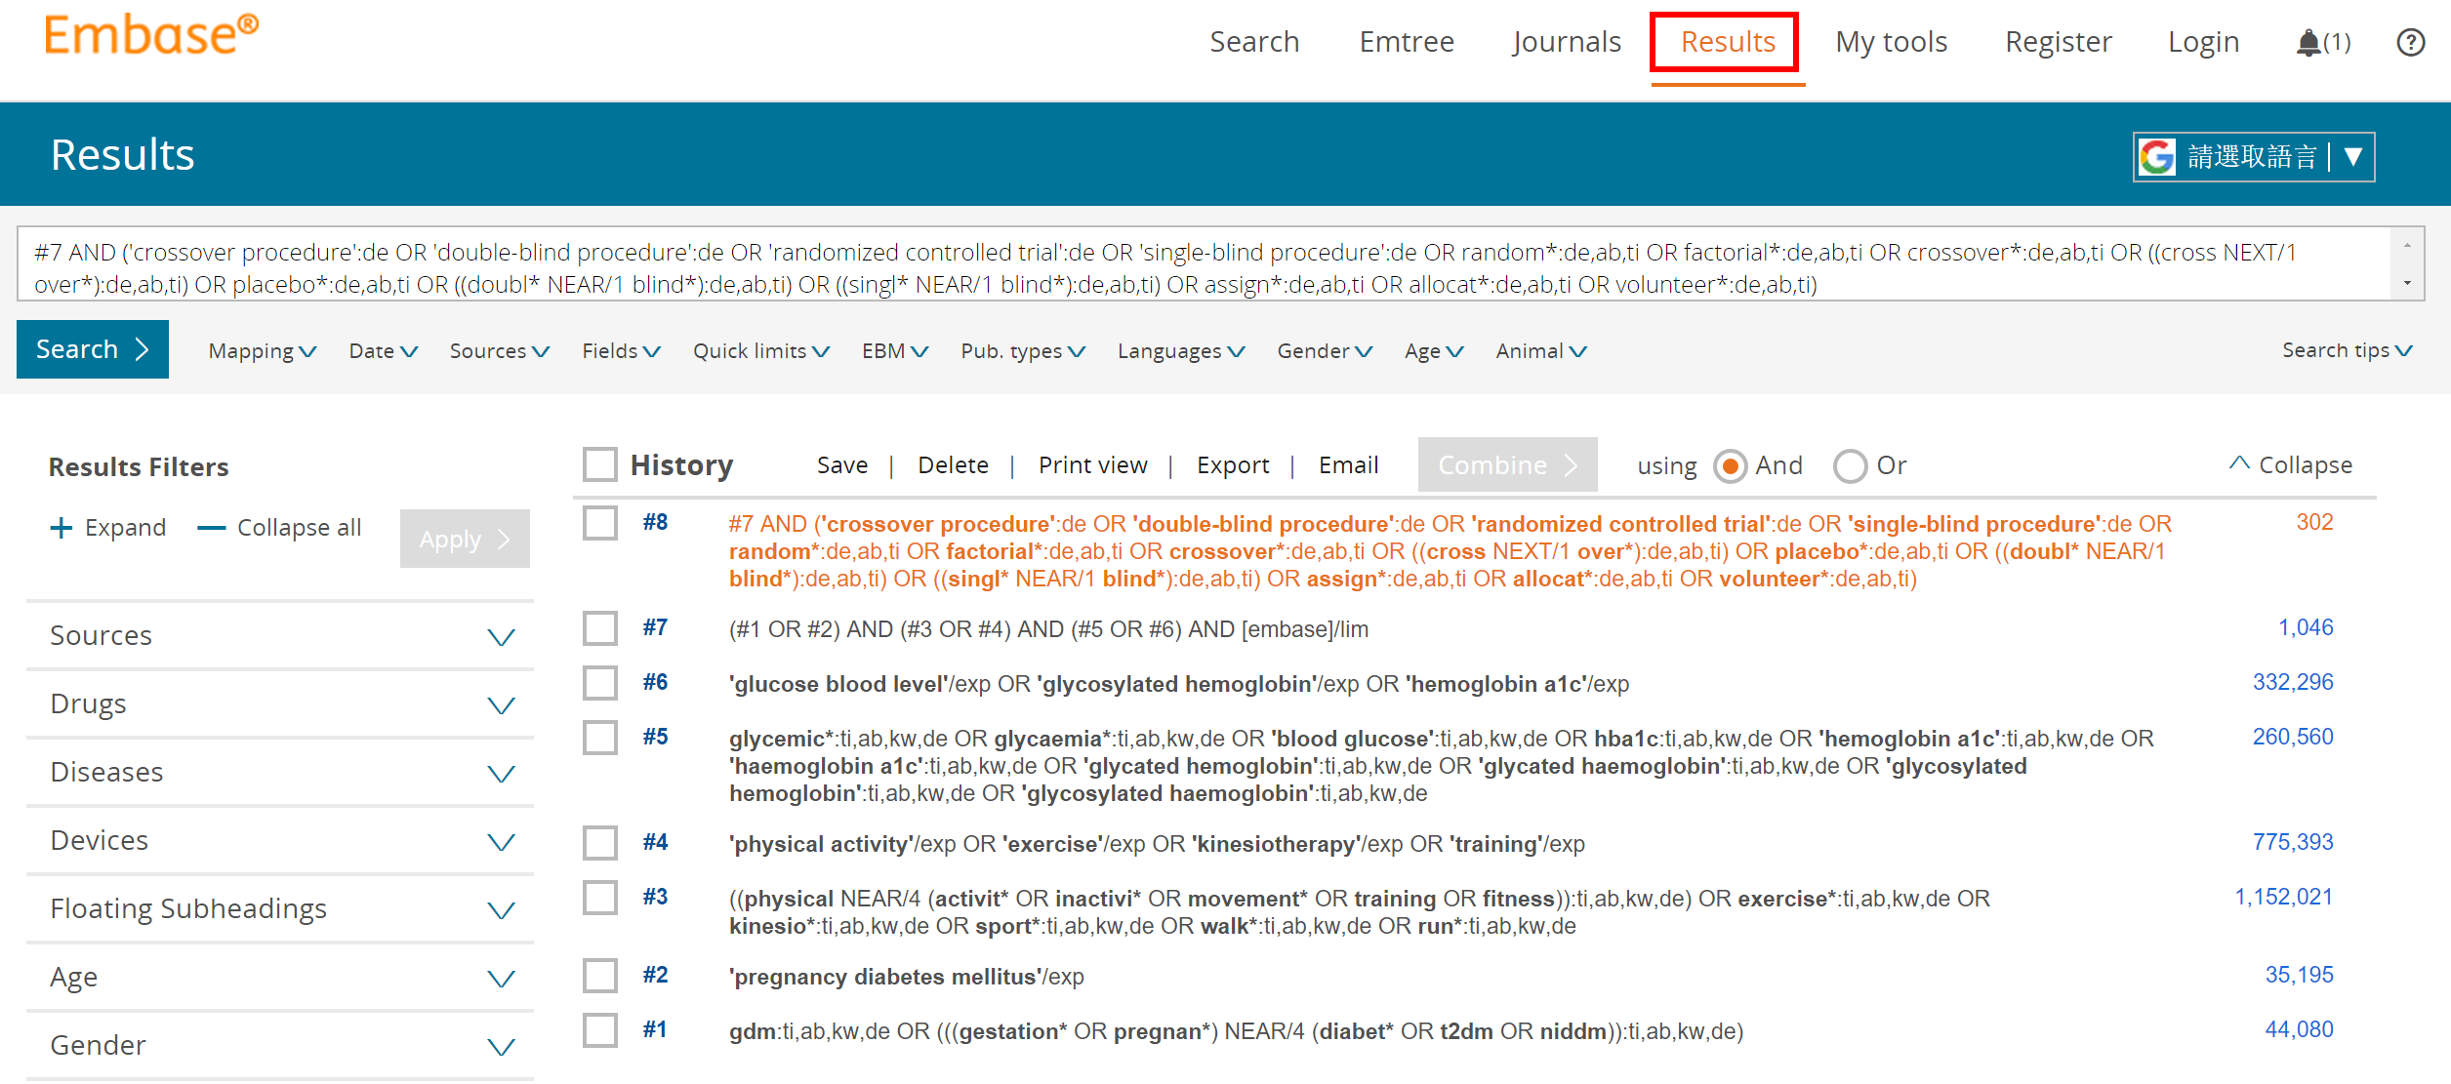

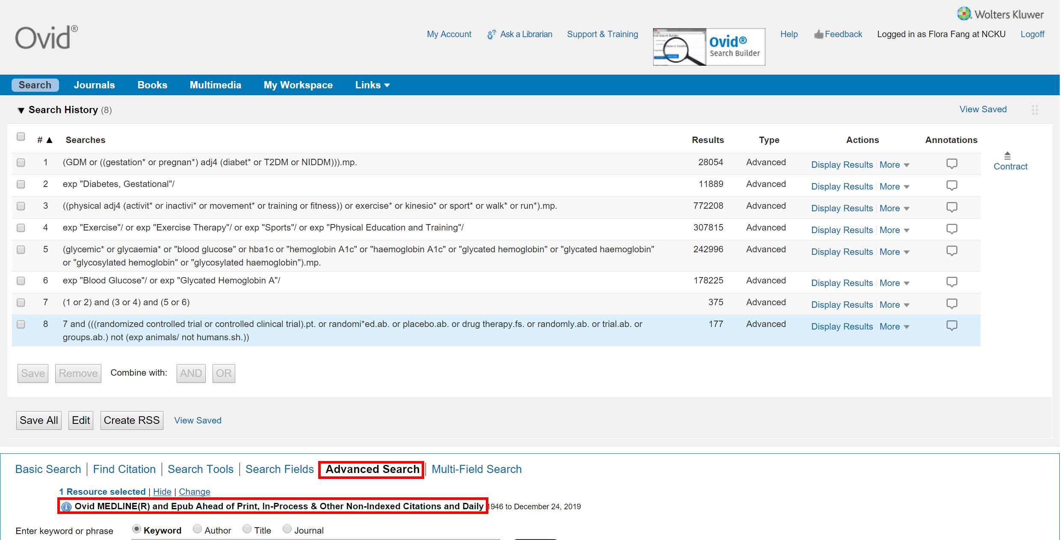

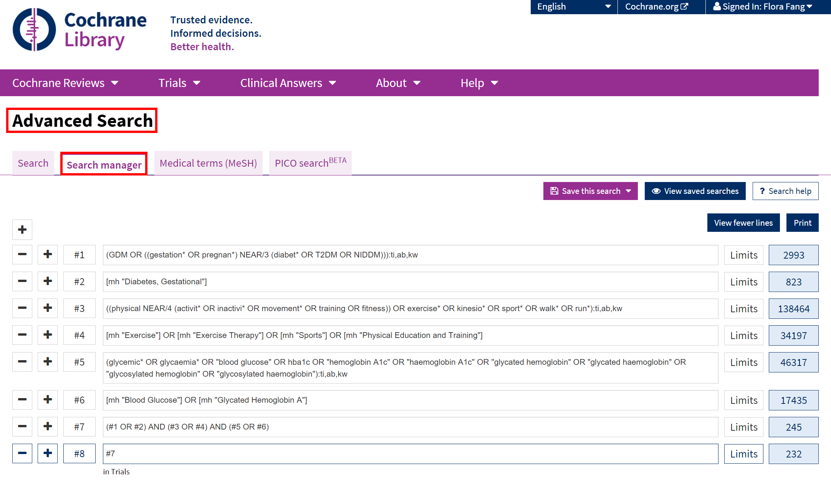

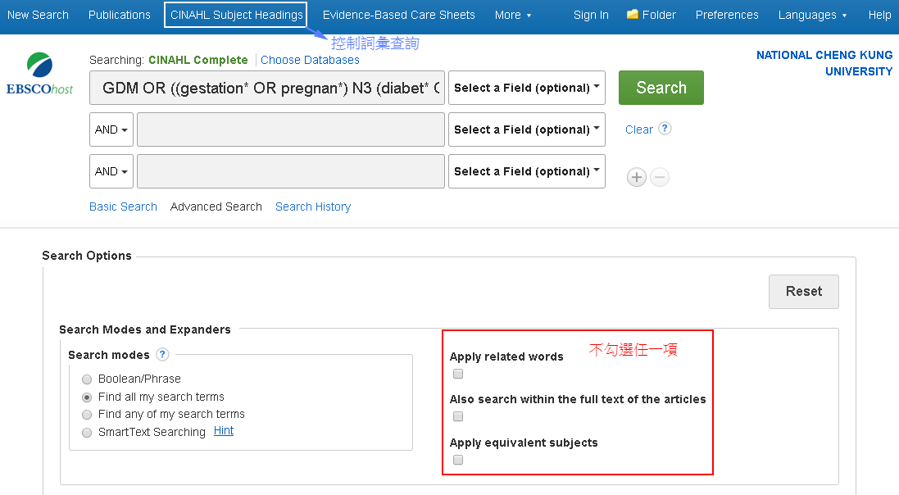

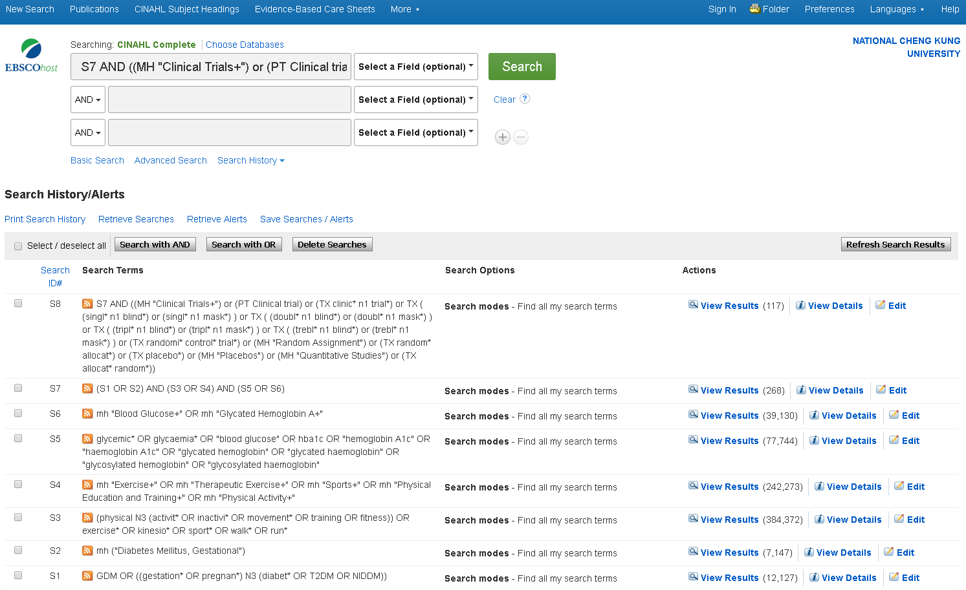

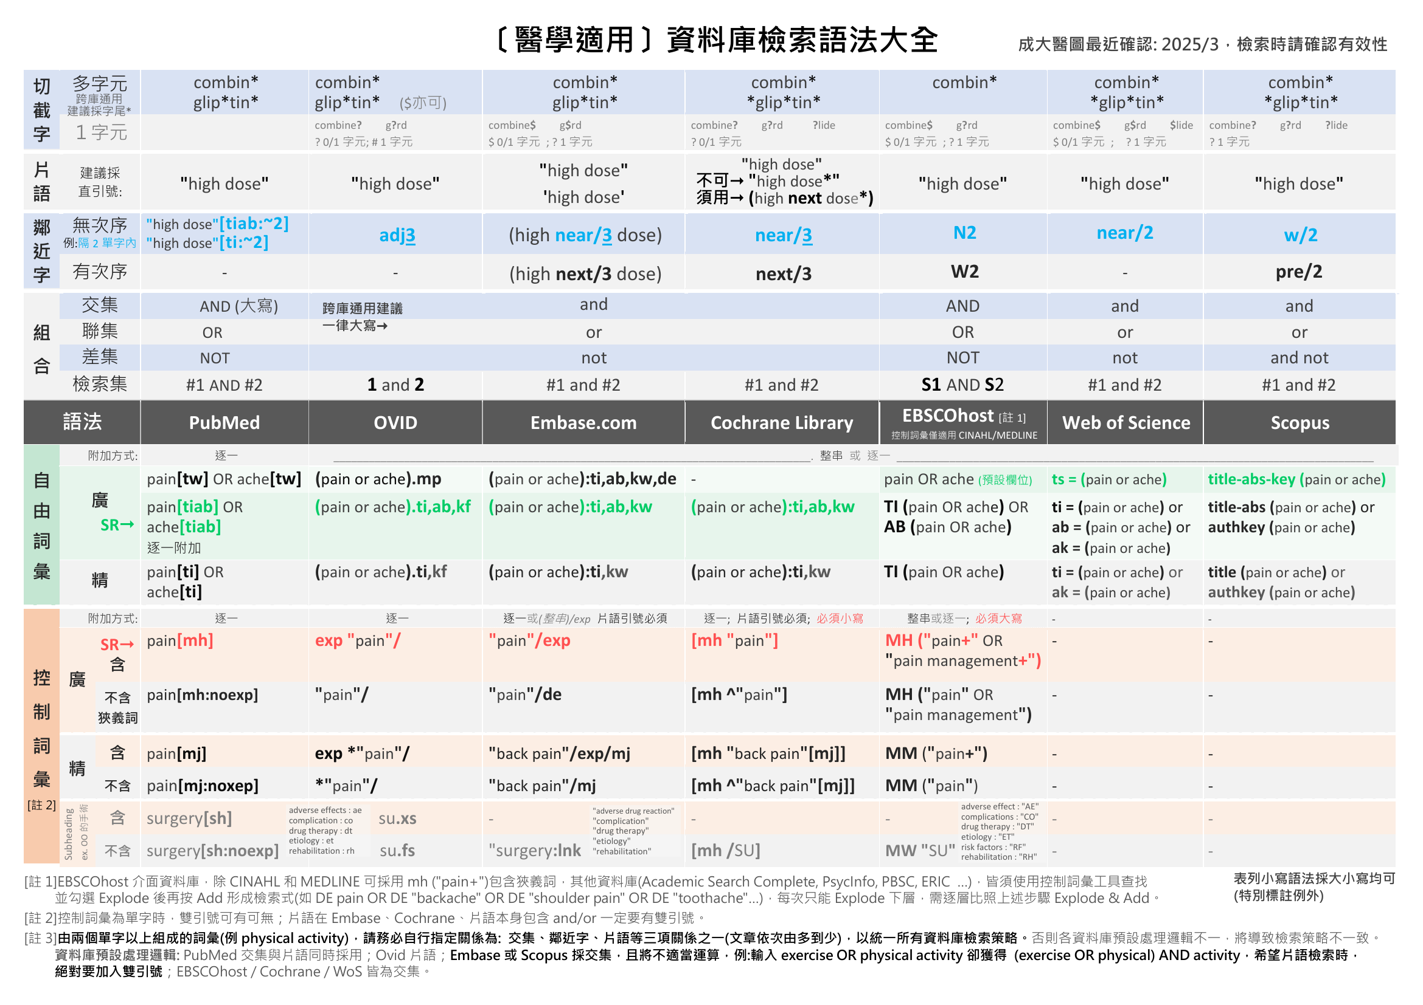

**附錄1**

**附錄2: 研究設計篩選語法：**不同問題類型/研究設計、資料庫/平台，套用的Filters各異

更多篩選語法：

CADTH <https://searchfilters.cda-amc.ca>

ISSG <https://sites.google.com/a/york.ac.uk/issg-search-filters-resource/>

更多篩選語法：

CADTH <https://searchfilters.cda-amc.ca>

ISSG <https://sites.google.com/a/york.ac.uk/issg-search-filters-resource/>

**附錄2-1: RCT** (Cochrane Trials: CENTRAL即收錄RCT，無須套用Filter)

|  |  |  |  |  |  |  |
| --- | --- | --- | --- | --- | --- | --- |
| **Embase.com (Elsevier)** | **Embase (Ovid)** | **Medline (Ovid)** | **Medline (PubMed)** | **CINAHL (EBSCOhost)** | **PsycInfo (Ovid)** | **Web of Science** |
| ("randomized controlled trial"/de or "controlled clinical study"/de or "randomization"/de or "intermethod comparison"/de or "double blind procedure"/de or "human experiment"/de OR (random* or placebo or "parallel group$" or crossover or "cross over" or assigned or allocated or volunteer or volunteers):ti,ab OR (open NEAR/1 label):ti,ab OR ((double or single or doubly or singly) NEAR/1 (blind or blinded or blindly)):ti,ab OR ((assign* or match or matched or allocation) NEAR/5 (alternate or group$ or intervention$ or patient$ or subject$ or participant$)):ti,ab OR (controlled NEAR/7 (study or design or trial)):ti,ab OR (compare or compared or comparison or trial):ti OR ((evaluated or evaluate or evaluating or assessed or assess) and (compare or compared or comparing or comparison)):ab) NOT (((random* NEAR/1 sampl* NEAR/7 ("cross section*" or questionnaire$ or survey* or database$)):ti,ab not ("comparative study"/de or "controlled study"/de or "randomi$ed controlled":ti,ab or "randomly assigned":ti,ab)) OR ("cross-sectional study"/de not ("randomized controlled trial"/de or "controlled clinical study"/de or "controlled study"/de or "randomi$ed controlled":ti,ab or "control group$":ti,ab)) OR ((((case NEAR/1 control*) and random*) not "randomi$ed controlled"):ti,ab) OR (("systematic review" not (trial or study)):ti) OR ((nonrandom* not random*):ti,ab) OR ("random field*":ti,ab) OR (("random cluster" NEAR/3 sampl*):ti,ab) OR ((review:ab and review/it) not trial:ti) OR ("we searched":ab and (review:ti or review/it)) OR ("update review":ab) OR ((databases NEAR/4 searched):ab) OR ((rat or rats or mouse or mice or swine or porcine or murine or sheep or lambs or pigs or piglets or rabbit or rabbits or cat or cats or dog or dogs or cattle or bovine or monkey or monkeys or trout or marmoset*):ti and "animal experiment"/de) OR ("animal experiment"/de not ("human experiment"/de or "human"/de)))  Filter Source: Box 3.e, [Technical Supplement to Chapter 4: Searching for and Selecting Studies](https://training.cochrane.org/handbook/version-6/chapter-4-tech-suppl). Cochrane Handbook for Systematic Reviews of Interventions Version 6. (Syntax Translated from Ovid Embase to Elsevier Embase.com. 原出處Ovid Embase版，且為逐行檢索，此已由成大醫圖轉換並合併為一串)  (若此語法找出總文章量過多，可以洽詢改用其他RCTs語法) | **(**(Randomized controlled trial/) OR (Controlled clinical study/) OR (random$.ti,ab.) OR (randomization/) OR (intermethod comparison/) OR (placebo.ti,ab.) OR ((compare or compared or comparison).ti.) OR (((evaluated or evaluate or evaluating or assessed or assess) and (compare or compared or comparing or comparison)).ab.) OR ((open adj label).ti,ab.) OR (((double or single or doubly or singly) adj (blind or blinded or blindly)).ti,ab.) OR (double blind procedure/) OR (parallel group$1.ti,ab.) OR ((crossover or cross over).ti,ab.) OR (((assign$ or match or matched or allocation) adj5 (alternate or group$1 or intervention$1 or patient$1 or subject$1 or participant$1)).ti,ab.) OR ((assigned or allocated).ti,ab.) OR ((controlled adj7 (study or design or trial)).ti,ab.) OR ((volunteer or volunteers).ti,ab.) OR (human experiment/) OR (trial.ti.)**) NOT (**(random$ adj sampl$ adj7 ("cross section$" or questionnaire$1 or survey$ or database$1).ti,ab.) not (comparative study/ or controlled study/ or randomi?ed controlled.ti,ab. or randomly assigned.ti,ab.) OR (Cross-sectional study/ not (randomized controlled trial/ or controlled clinical study/ or controlled study/ or randomi?ed controlled.ti,ab. or control group$1.ti,ab.)) OR ((((case adj control$) and random$) not randomi?ed controlled).ti,ab.) OR ((Systematic review not (trial or study)).ti.) OR ((nonrandom$ not random$).ti,ab.) OR ("Random field$".ti,ab.) OR ((random cluster adj3 sampl$).ti,ab.) OR ((review.ab. and review.pt.) not trial.ti.) OR ("we searched".ab. and (review.ti. or review.pt.)) OR ("update review".ab.) OR ((databases adj4 searched).ab.) OR ((rat or rats or mouse or mice or swine or porcine or murine or sheep or lambs or pigs or piglets or rabbit or rabbits or cat or cats or dog or dogs or cattle or bovine or monkey or monkeys or trout or marmoset$1).ti. and animal experiment/) OR (Animal experiment/ not (human experiment/ or human/))**)**  Filter Source: Box 3.e, [Technical Supplement to Chapter 4: Searching for and Selecting Studies](https://training.cochrane.org/handbook/version-6/chapter-4-tech-suppl). Cochrane Handbook for Systematic Reviews of Interventions Version 6. (原出處為逐行檢索，此已由成大醫圖合併為一串) | **sensitivity-maximizing (優先採用):**  (randomized controlled trial.pt. or controlled clinical trial.pt. or randomi*ed.ab. or placebo.ab. or drug therapy.fs. or randomly.ab. or trial.ab. or groups.ab. not (exp animals/ not humans.sh.))  Filter Source: Box 3.c, [Technical Supplement to Chapter 4: Searching for and Selecting Studies.](https://training.cochrane.org/handbook/version-6/chapter-4-tech-suppl) Cochrane Handbook for Systematic Reviews of Interventions Version 6. (Add: randomised.ab) | **sensitivity-maximizing(優先採用):**  (randomized controlled trial[pt] OR controlled clinical trial[pt] OR randomi*ed[tiab] OR placebo[tiab] OR drug therapy[sh] OR randomly[tiab] OR trial[tiab] OR groups[tiab] NOT (animals[mh] NOT humans[mh]))  Filter Source: Box 3.a, [Technical Supplement to Chapter 4: Searching for and Selecting Studies.](https://training.cochrane.org/handbook/version-6/chapter-4-tech-suppl) Cochrane Handbook for Systematic Reviews of Interventions Version 6. (Add: randomized[tiab]) | ((MH ("randomized controlled trials" OR "double‐blind studies" OR "single‐blind studies" OR "random assignment" OR "pretest‐posttest design" OR "cluster sample") OR TI (randomised OR randomized) OR AB (random*) OR TI (trial) OR (MH (sample size) AND AB (assigned OR allocated OR control)) OR MH (placebos) OR PT (randomized controlled trial) OR AB (control W5 group) OR MH ("crossover design" OR "comparative studies") OR AB (cluster W3 RCT)) NOT ((MH ("animals+" OR "animal studies") OR TI (animal model*)) NOT MH (human)))  Filter Source: Box 3.f., [Technical Supplement to Chapter 4: Searching for and Selecting Studies.](https://training.cochrane.org/handbook/version-6/chapter-4-tech-suppl) Cochrane Handbook for Systematic Reviews of Interventions Version 6. | **Watson et al:**  ("Treatment Effectiveness Evaluation"/ OR exp "Treatment Outcomes"/ OR "Placebo"/ OR "Followup Studies"/ OR (placebo* OR random* OR "comparative stud*" OR (clinical ADJ4 trial*) OR (research ADJ4 design) OR (evaluat* ADJ4 stud*) OR (prospectiv* ADJ4 stud*) OR ((singl* OR doubl* OR trebl* OR tripl*) ADJ4 (blind* OR mask*))).mp)  **Eady et al:**  **Best sensitivity:**  ((random* OR control*).mp OR exp "treatment"/)  **Best optimization of sensitivity and specificity:** ("double-blind" OR "random* assigned" OR control).mp  Filter Source: Eady AM, Wilczynski NL, Haynes RB. PsycINFO search strategies identified methodologically sound therapy studies and review articles for use by clinicians and researchers. Journal of Clinical Epidemiology. 2008 Jan;61(1):34-40.  本區參考[Cochrane](http://work.cochrane.org/psycinfo)推薦ProQuest介面語法，修改為Ovid介面語法 | (TS= clinical trial* OR TS=research design OR TS=comparative stud* OR TS=evaluation stud* OR TS=controlled trial* OR TS=follow-up stud* OR TS=prospective stud* OR TS=random* OR TS=placebo* OR TS=(single blind*) OR TS=(double blind*))  Filter Source: [American University of Beirut](https://aub.edu.lb.libguides.com/c.php?g=329862&p=3023731) |
| **sensitivity- and precision-maximizing (折衷採用):**  (randomized controlled trial.pt. or controlled clinical trial.pt. or randomi*zed.ab. or placebo.ab. or clinical trials as topic.sh. or randomly.ab. or trial.ti. NOT (exp animals/ not humans.sh.))  Filter Source: Box 3.d, [Technical Supplement to Chapter 4: Searching for and Selecting Studies.](https://training.cochrane.org/handbook/version-6/chapter-4-tech-suppl) Cochrane Handbook for Systematic Reviews of Interventions Version 6. (Add: randomised.ab) | **sensitivity- and precision-maximizing (折衷採用):**  (randomized controlled trial[pt] OR controlled clinical trial[pt] OR randomi*ed[tiab] OR placebo[tiab] OR clinical trials as topic[mesh:noexp] OR randomly[tiab] OR trial[ti] NOT (animals[mh] NOT humans [mh]))  Filter Source: Box 3.b, [Technical Supplement to Chapter 4: Searching for and Selecting Studies.](https://training.cochrane.org/handbook/version-6/chapter-4-tech-suppl) Cochrane Handbook for Systematic Reviews of Interventions Version 6. (Add: randomized[tiab]) | **Scopus** |
| (INDEXTERMS ( "clinical trials" OR "clinical trials as a topic" OR "randomized controlled trial" OR "Randomized Controlled Trials as Topic" OR "controlled clinical trial" OR "Controlled Clinical Trials" OR "random allocation" OR "Double-Blind Method" OR "Single-Blind Method" OR "Cross-Over Studies" OR "Placebos" OR "multicenter study" OR "double blind procedure" OR "single blind procedure" OR "crossover procedure" OR "clinical trial" OR "controlled study" OR "randomization" OR "placebo" ) OR TITLE-ABS-KEY ( "clinical trials" OR "clinical trials as a topic" OR "randomized controlled trial" OR "Randomized Controlled Trials as Topic" OR "controlled clinical trial" OR "Controlled Clinical Trials as Topic" OR "random allocation" OR "randomly allocated" OR "allocated randomly" OR "Double-Blind Method" OR "Single-Blind Method" OR "Cross-Over Studies" OR "Placebos" OR "cross-over trial" OR "single blind" OR "double blind" OR "factorial design" OR "factorial trial" ) OR TITLE ( clinical trial OR trial OR rct* OR random* OR blind* ))    Filter Source: [This filter is built by NUS Medical Library](https://libguides.nus.edu.sg/c.php?g=145717&p=2470589) using MESH and EMTREE terms as Index terms and Keywords. Useful to search in Scopus for RCTs.  紅字經修改有異於原始出處者 |
| **PsycInfo (EBSCOhost)** |
| **Watson et al:**  (DE ("Treatment Effectiveness Evaluation" OR "Treatment Outcomes" OR "Psychotherapeutic Outcomes" OR "Placebo" OR "Followup Studies") OR (placebo* OR random* OR "comparative stud*" OR (clinical N3 trial*) OR (research N3 design) OR (evaluat* N3 stud*) OR (prospectiv* N3 stud*) OR ((singl* OR doubl* OR trebl* OR tripl*) N3 (blind* OR mask*)))  Filter Source: Watson RJ, Richardson PH. Identifying randomized controlled trials of cognitive therapy for depression: comparing the efficiency of Embase, Medline and PsycINFO bibliographic databases. Br J Med Psychol. 1999 Dec;72 ( Pt 4):535-42.  **Eady et al:**  **Best sensitivity:** EBSCOhost介面無法直接以單一符號表示包含狹義詞，逐一列出數量太龐大，因此不予轉譯  **Best optimization of sensitivity and specificity:** ("double-blind" OR "random* assigned" OR control)  Filter Source: Eady AM, Wilczynski NL, Haynes RB. PsycINFO search strategies identified methodologically sound therapy studies and review articles for use by clinicians and researchers. Journal of Clinical Epidemiology. 2008 Jan;61(1):34-40.  本區參考[Cochrane](http://work.cochrane.org/psycinfo)推薦ProQuest介面語法，修改為EBSCOhost介面語法 |

**附錄2-2: Quasi Experimental Study 類實驗** (不同問題類型/研究設計、資料庫/平台，套用的Filters各異，如有需要請洽詢)

|  |  |  |  |  |  |
| --- | --- | --- | --- | --- | --- |
| **Embase.com [Elsevier]** | **Medline [Ovid]** | **Medline [PubMed]** | **CINAHL [EBSCOhost]** | **PsycInfo [Ovid]** | **Web of Science** |
| ((pretest* OR posttest* OR "pre test" OR "post test*" OR "quasi experiment*" OR quasiexperiment* OR "repeated measure*" OR "time series"):ti,ab,kw **OR** "pretest posttest design"/exp OR "pretest posttest control group design"/exp OR "quasi experimental study"/exp OR "time series analysis "/exp) | (pretest* OR posttest* OR "pre test" OR "post test*" OR "quasi experiment*" OR quasiexperiment* OR "repeated measure*" OR "time series").mp | (pretest*[tw] OR posttest*[tw] OR "pre test"[tw] OR "post test*"[tw] OR "quasi experiment*"[tw] OR quasiexperiment*[tw] OR "repeated measure*"[tw] OR "time series"[tw]) | ((pretest* OR posttest* OR "pre test" OR "post test*" OR "quasi experiment*" OR quasiexperiment* OR "repeated measure*" OR "time series") **OR** MH ("pretest-posttest design+" OR "pretest-posttest control group design+" OR "quasi-experimental studies+")) | ((pretest* OR posttest* OR "pre test" OR "post test*" OR "quasi experiment*" OR quasiexperiment* OR "repeated measure*" OR "time series").mp OR exp "Pretesting"/ OR exp "Posttesting"/ OR exp "Quasi Experimental Methods "/ OR exp "Repeated Measures"/ OR exp "Time Series"/) | TS = (pretest* OR posttest* OR "pre test" OR "post test*" OR "quasi experiment*" OR quasiexperiment* OR "repeated measure*" OR "time series") |
| **PsycInfo [EBSCOhost]** |
| (pretest* OR posttest* OR "pre test" OR "post test*" OR "quasi experiment*" OR DE (quasiexperiment* OR "Repeated Measures" OR "time series") **OR** **"Pretesting" OR "Posttesting" OR "Quasi Experimental Methods" OR "Repeated Measure" OR "Time Series")** |
| **Scopus** |
| title-abs-key (pretest* OR posttest* OR "pre test" OR "post test*" OR "quasi experiment*" OR quasiexperiment* OR "repeated measure*" OR "time series") |
| **Psychology and Behavioral Sciences Collection: PBSC (EBSCOhost)** |
| **--** |